**LI: To write a monologue from the ships point of view**

**A monologue is a conversation you have with yourself where you can express your inner most thoughts and feelings about an event, person, place. It helps us to understand a persons character.**

First I need to understand the object I will be – in this case from Shackleton’s Ship “The Endurance”

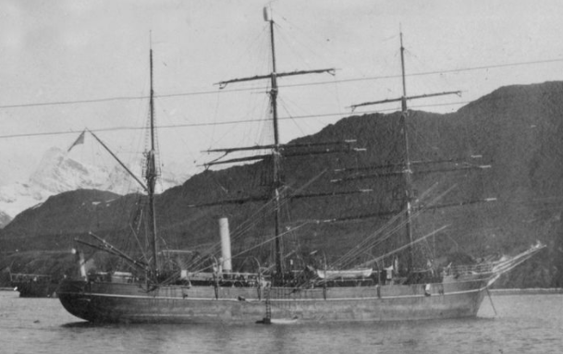

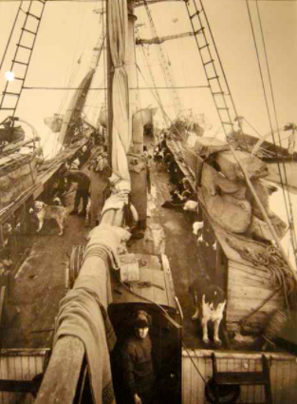

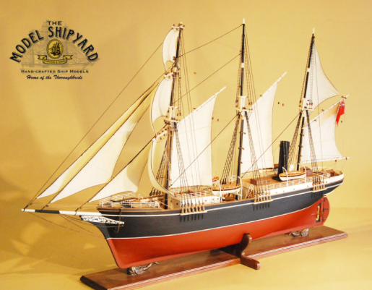

Next I need to understand how a ship moves on and through water:

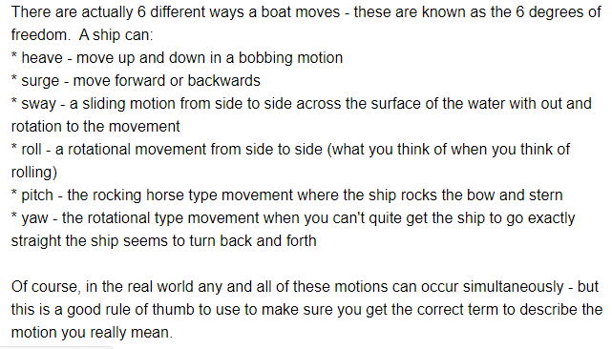

Next, I need to have a good range of similes to help me to describe the ship and its surroundings:

A simile describes 2 things using as or like:

* The ship was as strong as an ox
* The bows rumbled like thunder as the load was secured
* The ship glides like a graceful swan

Lastly, I need to have a good range of metaphors to help me to describe the ship and its surroundings:

A metaphor describes an object as if it is that object:

* Hammer pounded nails into my head
* The ocean is a blue mirror
* I feel light and comfortable

A few images can help me get my creative juices flowing:

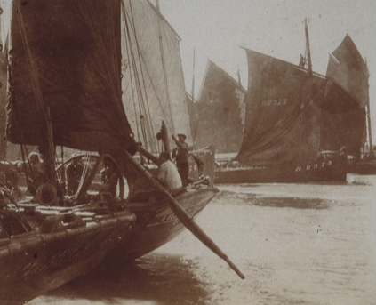 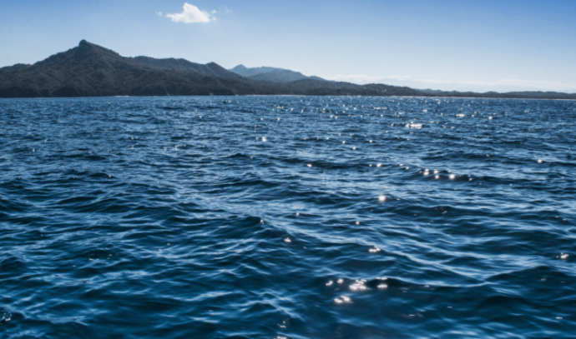

A busy harbour in the 1910’s An ocean coastline

My name is Endurance; actually, it used to be Polaris, but my new owner thought a new name and a fresh lick of paint would mirror his feelings towards his latest adventure. I’m sitting here in the harbour, waves gently licking my bow, bobbing and rocking gently side to side as more and more cargo is added to my already heaving stores. The weight pulling me lower into the water. Oh, how I do wish they would hurry up! The crew scurry about their business like rats up a drainpipe! My quest, so I have been told is to transport the crew to the frozen kingdom of Antarctica. I have never sailed that far south before – I hope its not too chilly there! I cannot wait to glide like a swan out of the harbour and fill my sails with fresh sea air. I do hope these dogs settle down- their hustling keeps tickling at my ribs!

