Character profile:

Frank Wild

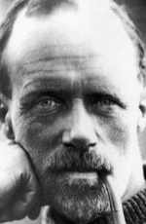

Who is Captain Frank Wild?

He is a male celebrity.

He was born on Thursday April 10th 1873, in Skelton, North Yorkshire, England, UK,.

Captain Frank Wild holds great compassion and seeks to be of service to others. He is a healer, and capable of giving comfort to those in need - he will frequently offer a shoulder for others to cry on. But actually, Captain's mission in life is to develop the tools that allow him to be truly helpful to others rather than just a sympathetic ear. Captain Frank Wild must find the balance between help and interference, and the delicate art of the counsellor who knows when to leave the struggle to others and when to avoid taking away the necessary experiences and lessons of life.