Who was Frank Hurley?

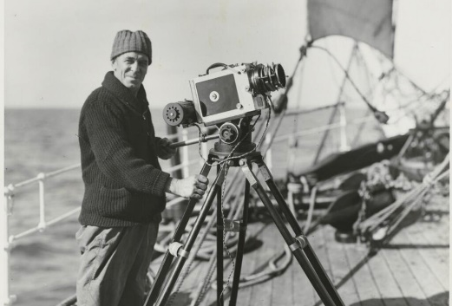

James Francis "Frank" Hurley OBE (15 October 1885 – 16 January 1962) was an Australian photographer and adventurer. He participated in a number of expeditions to Antarctica and served as an official photographer with Australian forces during both world wars.  
His artistic style produced many memorable images. He also used staged scenes, composites and photographic manipulation.

**The only member of Shackleton's expedition that Shackleton didn't meet or interview before the expedition** set off, Hurley was accepted on the the strength of his work with Mawson on the 1911-13 Australasian Antarctic Expedition.

Hurley joined Shackleton's Endurance expedition at six weeks notice meeting the ship in Buenos Aires after travelling from Australia. He had been warned by Mawson to make an arrangement with Shackleton whereby he was paid a percentage of the profits of the expedition. It was in Shackleton's financial interests to make sure that a full pictorial record of the expedition made it back home.

Hurley was tall and tough, his first impressions of the crew of the Endurance were not favourable thinking that their physiques were small and not up to standard of the men on Mawson's Australian Antarctic Expedition.

Nonetheless, he was as Greenstreet put it "a warrior with his camera & would go anywhere or do anything to get a picture". At that time a camera was a large wooden boxed structure weighing many pounds and requiring more wooden boxes of glass plates that were used to take the negatives. Even taking the simplest photograph was a significant undertaking and Hurley regularly hauled his equipment, 40 lbs of it and more to difficult places, to the top of the Endurance's masts or up peaks in South Georgia for instance.