What is a coordinating conjunction?
A coordinating conjunction is a conjunction that goes between, and links, words, phrases, clauses or sentences of equal importance.
Coordinating conjunction examples
- The walls were painted white and blue.
- My phone is either in my bag or on the table.
- I enjoy geography but not RE.
- I won’t eat chillies for they are too spicy for me.
- Stevie won’t drink milk, nor will he eat eggs.
- We cleared the table so we could play a board game.
- She doesn’t try very hard, yet she still does well.
Coordinating conjunctions list. There are only seven coordinating conjunctions:
And, But, For, Nor, Or, So, Yet
Remember FANBOYS
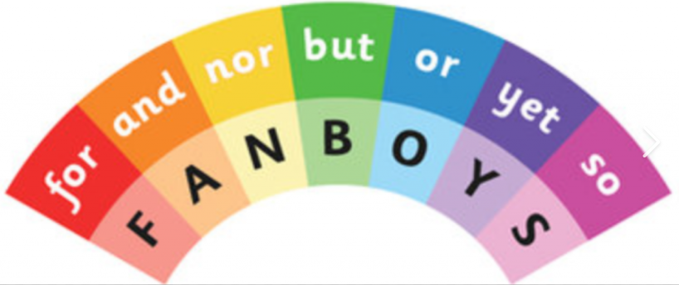

What is a subordinating conjunction?
A subordinating conjunction introduces a subordinating clause, and joins it to the main clause in a sentence.
Subordinating conjunction examples
- Gina has been thrilled ever since Jenny arrived.
- The dog is barking because he wants to go for a walk.
- We need to clean up so that the classroom is tidy for tomorrow morning.
- I like living here even though the neighbours can sometimes be noisy.
Subordinating conjunctions list:
After, Although, As, As if, As long as, Because, Before, Even though, If, If only, Now, Now that
Once, Provided, Rather than, Since, So that, Than, That, Though, Till, Unless, Until, When, Where
Whether, Which, While

