**What is a coordinating conjunction?**

A coordinating conjunction is a conjunction that goes between, and links, words, phrases, clauses or sentences of equal importance.

Coordinating conjunction examples

* The walls were painted white and blue.
* My phone is either in my bag or on the table.
* I enjoy geography but not RE.
* I won’t eat chillies for they are too spicy for me.
* Stevie won’t drink milk, nor will he eat eggs.
* We cleared the table so we could play a board game.
* She doesn’t try very hard, yet she still does well.

Coordinating conjunctions list. There are only seven coordinating conjunctions:

**And, But, For, Nor, Or, So, Yet**

**Remember FANBOYS**

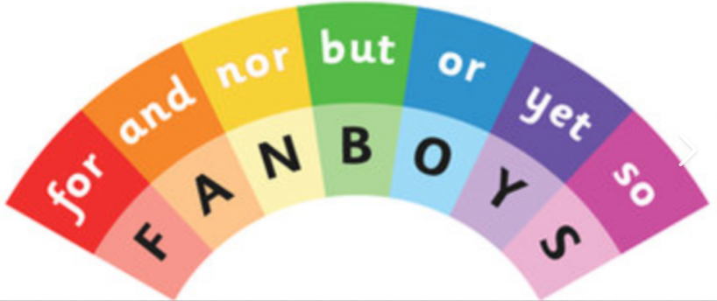

**What is a subordinating conjunction?**

A subordinating conjunction introduces a subordinating clause, and joins it to the main clause in a sentence.

Subordinating conjunction examples

* Gina has been thrilled ever since Jenny arrived.
* The dog is barking because he wants to go for a walk.
* We need to clean up so that the classroom is tidy for tomorrow morning.
* I like living here even though the neighbours can sometimes be noisy.

Subordinating conjunctions list:

After, Although, As, As if, As long as, Because, Before, Even though, If, If only, Now, Now that

Once, Provided, Rather than, Since, So that, Than, That, Though, Till, Unless, Until, When, Where

Whether, Which, While