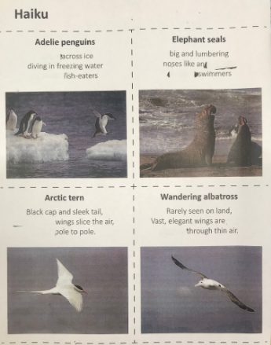

using their syllable counting and adjectives, verbs and nouns, can they fill the blanks of these haikus with their own words whilst keeping to the 5, 7, 5 rule. Starting at the penguins they get progressively harder (more blanks) how many can they do?
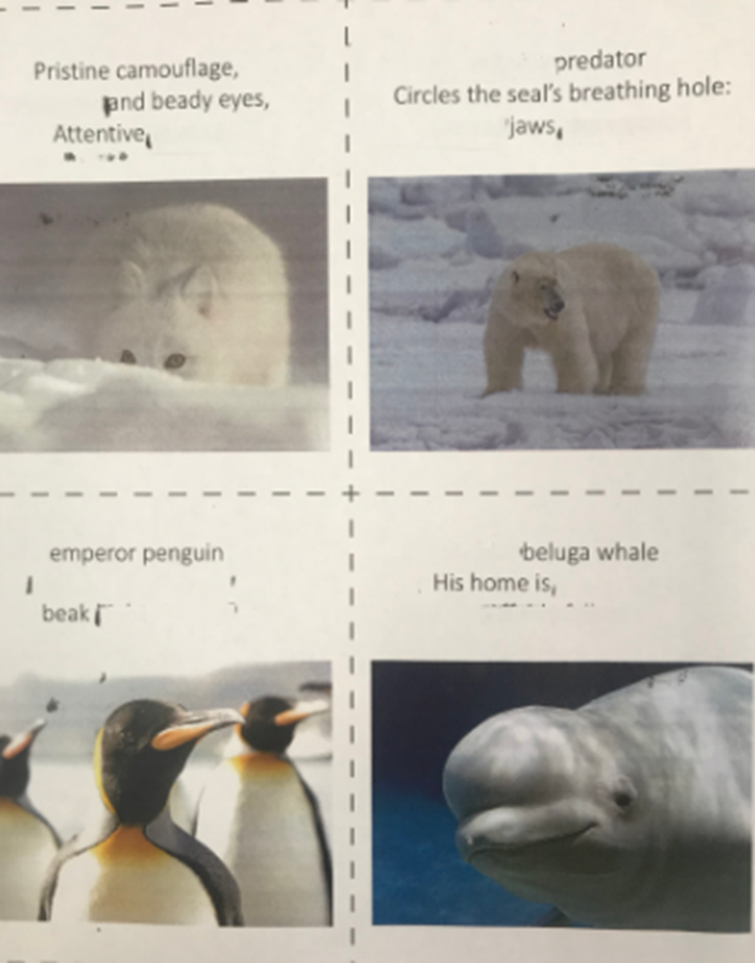

using their syllable counting and adjectives, verbs and nouns, can they fill the blanks of these haikus with their own words whilst keeping to the 5, 7, 5 rule. Starting at the penguins they get progressively harder (more blanks) how many can they do?

