Year 6 Model Text: Balanced argument

Home or Away
Where to go on holiday?
Everyone likes to try to get away at least once a year. The question is: where should you go? Of course, money is an important factor, but let’s imagine that you could afford to go wherever you wanted. Would that – should that – affect your choice of destination? Is it better to stay at home or go abroad?
For most holidaymakers, going abroad is the rare chance to enjoy a relaxing time in the sunshine. Many of the top holiday resorts overseas have reliably better weather than we do here in the UK, which is why they are so popular. After all, the last thing a family wants to do with its precious week away is to spend it miserably staring at the rain that often lashes the British Isles throughout August.
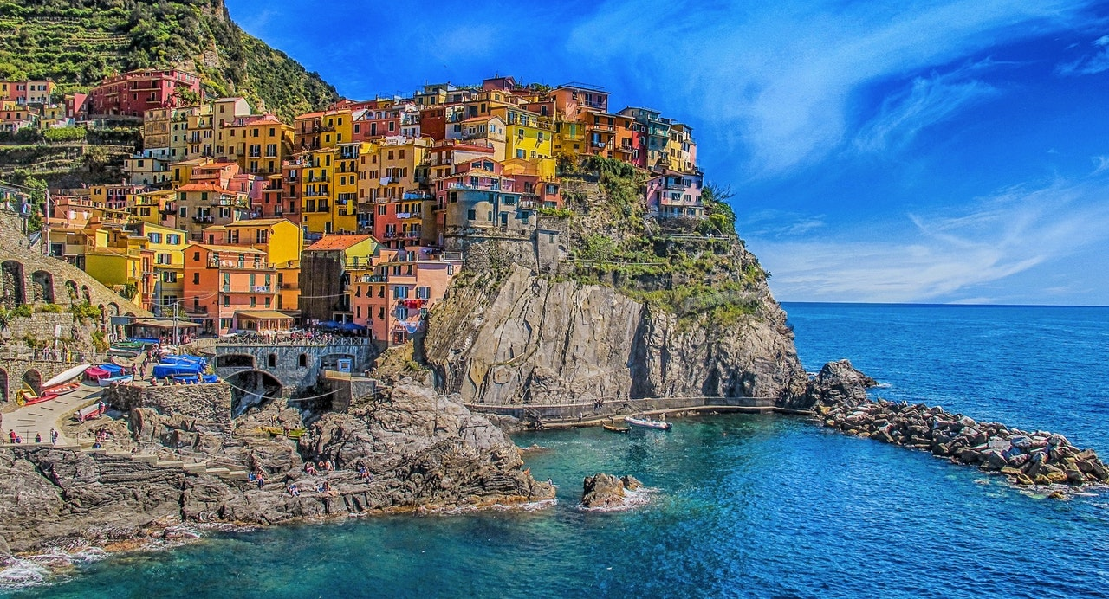
Holidays can be more than just a chance to top up your tan, however. By visiting other countries, you can get a better understanding of different people and foreign cultures. You might even be inspired to learn some of the language in order to communicate with local people. What’s more, by spending your holiday cash in their shops and restaurants, you will be helping to support families whose lives depend on tourism. On your own, you might think that you can only make a small difference, but if enough people do make the effort to go abroad, then it could help to promote better relations between nations, which has to be a good thing!
On the other hand, you might well argue that there are plenty of excellent reasons to enjoy a ‘staycation’ as it has become known. For a start, the UK is a wonderfully diverse and fascinating place. Whether you’re interested in history, culture, sporting activities or spectacular scenery, we have it all here in our own country. There are even plenty of wonderful beaches (where you don’t have to worry about what dangerous creatures might be lurking beneath the waves). Besides, the climate statistics for London, for example, show that the average temperatures remain above 20 degrees centigrade throughout the summer months. If it gets much warmer than that, then we British start complaining that it’s too hot!
But there’s another factor to consider: the environment. All travel causes some pollution, with cars and planes amongst the worst offenders when measured as carbon emissions per mile or kilometre. The trouble is that we tend to travel further distances by plane, so the environmental impact is greater. Furthermore, while you’re saving the planet by not holidaying abroad, you will also be making sure that the money you spend stays within our country. After all, as the saying goes, ‘charity begins at home’; why support shopkeepers overseas when ours also need all the help they can get?

So, what do you consider to be most important: sunshine and broader horizons, or looking after our own country as well as the environment? Perhaps you could compromise by going abroad some years and staying in the UK for others. How frequently you decide to choose each type of destination will depend on where your own personal priorities lie.

