Continue the story…
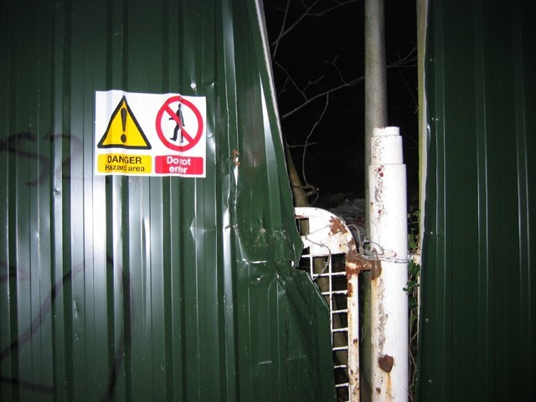
“Help me!” The words clearly emanated from behind the large iron fence surrounding the dilapidated, decaying hospital which had sat abandoned for over 30 years. “Help me!” Again, but with more urgency, they cut through the icy midnight darkness. A section of the barrier had been pulled away and a gap, just large enough to allow human entry, presented itself…

