Day | Blog Post | Documents/Photos  All photos to be uploaded to tapestry post.
Monday | Good morning, I hope you had a wonderful half term and enjoyed a little break away from your home learning. We are now in term 6! I cannot quite believe how fast the year has gone. There is a new home learning timetable for you with lots of activities to keep you busy through the day including phonics and handwriting.  Today for your home learning I would like you to practise ordering numbers 1 to 20. I know we have done this before, but remember the more we practise the better we get. If you are confident with 1 to 20, you can always challenge yourself to go further maybe you could order numbers 20 to 30!  First of all listen to the ‘Big Numbers’ song: https://www.youtube.com/watch?v=e0dJWfQHF8Y  Then I would like you to have a go at writing your own number cards and then ordering them. Maybe you could think of a fun creative way of doing this (there are some ideas below).  ** (add photos)  Have you been on Mathletics recently? I can see lots of you have been working very hard on this and have got lots of certificates, which is fantastic! Have a little go at Mathletics this afternoon, remember to check your email as I sent you all your log-ins a couple of weeks ago.  Have a great day exploring Maths! | Handwriting sheet: l  Add these photos into the blog here **  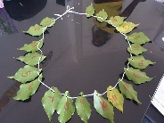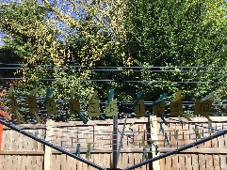  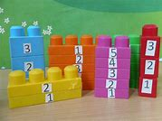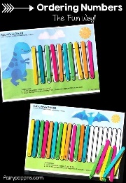
Tuesday | Hello everyone, how are you today?  So, as I said yesterday it is now Term 6 and a new term means a new topic, and our new topic is…..‘On The Farm’. We are going to be thinking lots about different animals and things that happen on a farm. Today I would like you to just have a think about this question….What do you already know about the farm? Perhaps then you would like to write the things you know, or create a picture. After you have thought of all the things you know about being on the farm, why not watch an episode of ‘Down on the Farm’ on Cbeebies: https://www.bbc.co.uk/cbeebies/shows/down-on-the-farm?page=2  Today, I would also like you to have a think about one of your friends, what makes them a good friend? Then I would like you to make something for your friend it may be a friendship bracelet or you may even make a picture or decorate a pebble for them.  Have a wonderful day | Handwriting sheet: i  Photos to be uploaded underneath this post, set layout: 4 across  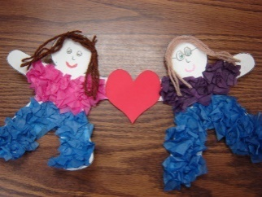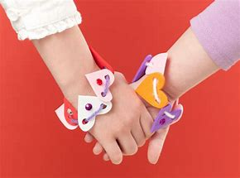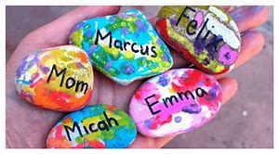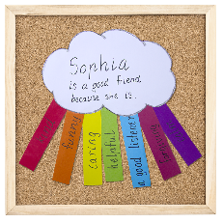
Wednesday | Good morning, and welcome to the middle of the week!  How did you get on with ordering numbers yesterday? I saw some children took on the challenge and went beyond 20, well done!!  Today, I would like you to focus on counting carefully. Remember when we count we need to say one number name for each object, so that our counting is accurate. Why not have a go at counting objects in the house, you may count the number of cars you have, or how many shoes each person in your home has, I wonder who has the most? Can you then write the numbers? If you are looking for a challenge why not see if you can count in 2s! A good way to do this would be to count socks or shoes.  ** photos in here  Then I would like you to get creative!! Can you use different materials to make a mask of a farm animal? This video teaches you how to make some animals masks using paper plates: https://www.youtube.com/watch?v=HYX_9aa92bo  Enjoy getting creative and don’t forget to send us a photo of you wearing your mask!! | Handwriting sheet: u  **  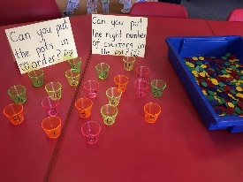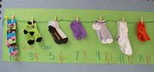  Photos to be added underneath set layout: 2 across  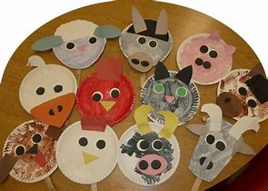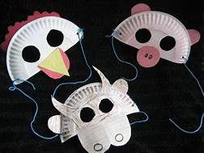
Thursday | Hello there everyone! Wow, isn’t this week going quickly….  Today I would like you to get musical! Why not start by singing some nursery rhymes, or maybe even have a dance and a sing to one of your favourite songs. Then see if you can follow these two songs: https://www.youtube.com/watch?v=VTmk_ADNOgg and https://www.youtube.com/watch?v=aXZWgOf2lSA (this one makes me smile). Then why not challenge the others in your house to a game of ‘Don’t clap this one back’!! Remember when you hear this one being clapped, put your hands behind your back!!  Then, let’s get those muscles moving and practise some throwing and catching, can you also roll a ball? What other ways are there of making a ball move?  Have a fantastic day!! | Handwriting sheet: t
Friday | It’s FRIDAY!! Which means….tomorrow is Saturday which is the weekend. I wonder what do you have planned for the weekend? Are you going on an exciting walking adventure? Are you having something special for dinner? Have a think and a chat with your family, what will you be doing? Can you then write a few sentences about this for me and draw a picture. How will you start your sentences, can you start each one a different way, for example ‘At the weekend I will….’, ‘On Saturday I…’, ‘I am going to…’  Don’t forget these important things when writing (I know sometimes it is easy to forget these!)  ** add picture in  I would also like you to do some R.E. head over to the R.E page on our class page to see which lesson it is, if you haven’t done any then start with lesson 1 but if you have then do lesson 5.  Have a wonderful weekend and have lots of fun! | Handwriting sheet: y  **  