Term 5: Week 3
This week for home learning you may like to…
Phonics: Phase 4, week 4:  Reading HFW (high Frequency Words) and sentences. |  |  |  | Practise recognition & recall of Phase 2 & 3 graphemes  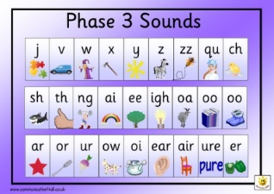
Literacy | Maths | Physical Development | Understanding the world |  | Expressive arts and Design | Personal, Social, Emotional, Development | R.E
To write a list of ingredients.  Look at vegetable recipes. Children to decide on their own recipe to write for a vegetable dish. Then write a list of ingredients.  https://www.bbcgoodfood.com/recipes/collection/vegetarian-kids | To name and describe 3D shapes.  Naming 3d shapes and some of their properties.  https://www.youtube.com/watch?v=guNdJ5MtX1A  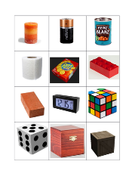  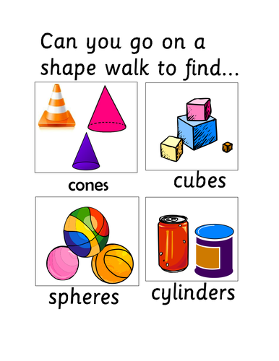 | -To play a simple team game with a scoring system.  -To show improved hand and eye co-ordination.  -To experiment using a bat in a variety of ways.  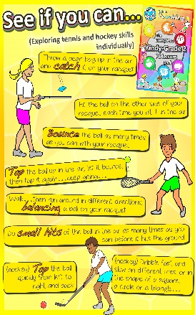 | To draw a map  Have a look at different maps, see if you can find the school or your house on google maps.  Then, draw a map of your very own. It may be a map of your route to school or to the shop. It may be a map of a park or garden.  Here is a link to a map template:  https://littleowlsresources.com/treasure-maps |  | Move like wildlife.  Put some music on and move like different animals:. E.g: wiggle like a worm. Hop like a rabbit.  BBC lets move (there are 3 episodes to this) https://www.bbc.co.uk/programmes/b03g6hf4  Animal warm up:  https://www.youtube.com/watch?v=MugzDjGDYjo  Insect dance:  https://www.youtube.com/watch?v=7xyXB8_BetQ | Make up a new board game, explain to others how to play it so that they understand.  Here are some templates you may like to use:  https://www.twinkl.co.uk/resource/t-c-791-blank-editable-board-games | What is a promise?  Noah’s Ark Rainbow  Ask the children how they feel about things being made a mess.  https://www.youtube.com/watch?v=2JZHXkI9BB4Read or Listen to the Noah’s Ark story.  God cleaned the world and started again. He then promised that however  messy it got, God would not send a flood like that again. What other promises have the children seen?  Emphasise that promises are really important and you should really  think before saying ‘I promise’.  Make something to represent the promises children want to make.  