Continue the story…
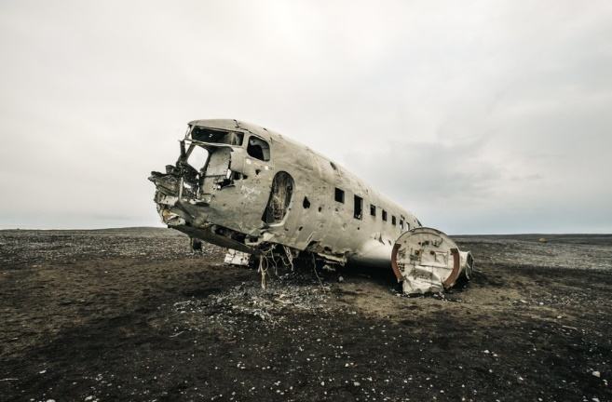
With the weather closing in, and night about to fall, the survivors needed to work urgently to create a shelter and some form of message that could be seen by those searching for them from above…

