Continue the story…
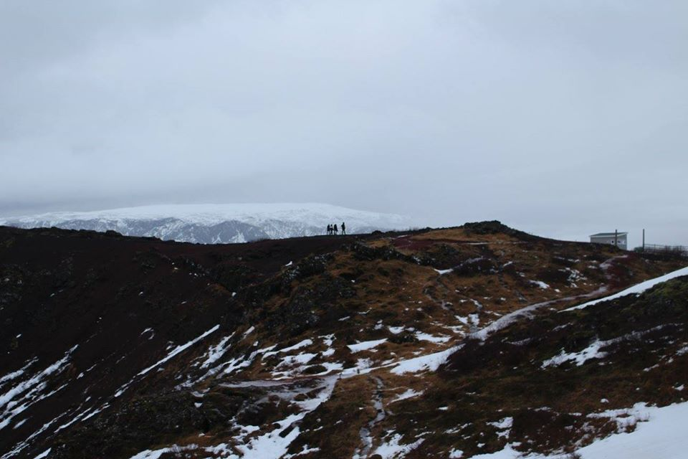
Through the howling winds and icy gales, I suddenly saw them. Tiny black dots against the distant snow-capped mountain tops. Why were they here? What did they want? How had they found me?

