**Tuesday 21st July 2020**

Today is the penultimate day of the school year. As we swiftly move towards the end of the school year, we should enter a natural period of reflection. There is a meme that has gone viral that sums up living in lockdown:

“We are all in the same storm but travelling in different boats”

* What does this mean to you?
* What does this mean to your family?
* What have you done to ride out the storm and cope in lockdown?

**Activity 1:**

Read the poem below. Think about the words and the message they give. What images does create in your mind? How does it make you feel? What poetic features can you see or hear as you read it?

**"When it is safe, I’ll hold my arms open wide,**

**and shout to the world we can all go outside!**

**Don’t give up hope the end is in sight,**

**if we all stick together, we’ll all win this fight!”**

**Task 1:**

Write a lockdown poem of your own to express how you feel and what you are looking forward to most.

**Activity 2:**

Look at this meme:

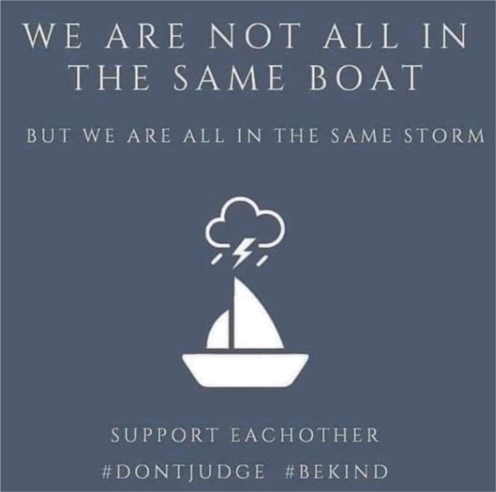

**Task 2:**

Create a poster to be displayed in school in September that uses this message and the hashtags #DONTJUDGE #BEKIND #ABCFAMILY

**Activity 3:**

Look at the image below.

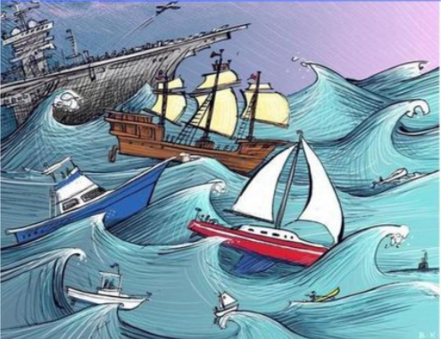

**Task 3:**

Create your own storm and boats picture.

* Use colour and tone to add atmosphere
* Use lines and patterns to create details.
* Use shading to create 3D shapes

**Task 4:**

In the Bible there is symbolism behind the story of Jesus calming the storm. This may bring great encouragement and hope for anyone facing a storm in life – Just like lockdown. Read the 3 recounts of the story of Jesus calming the storm from the points of view of the disciples.

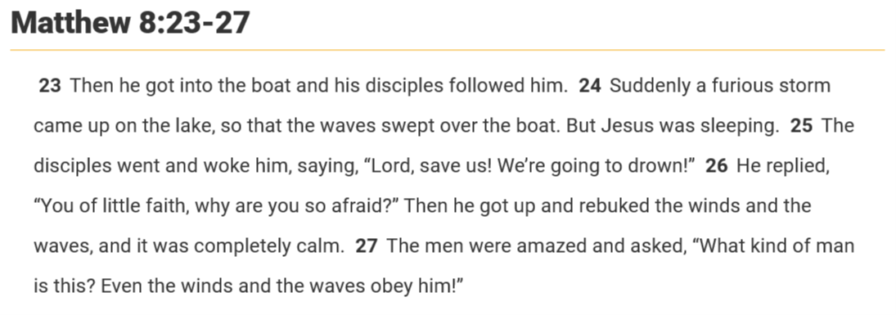

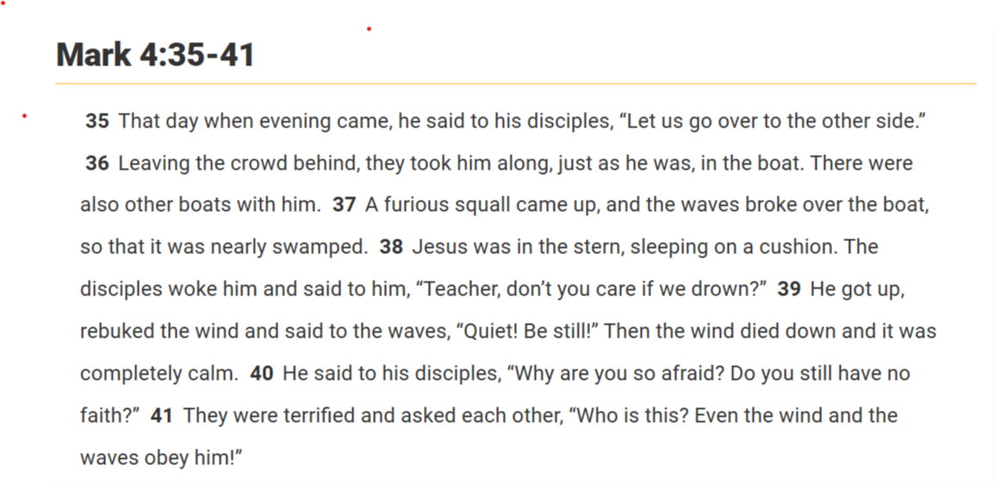

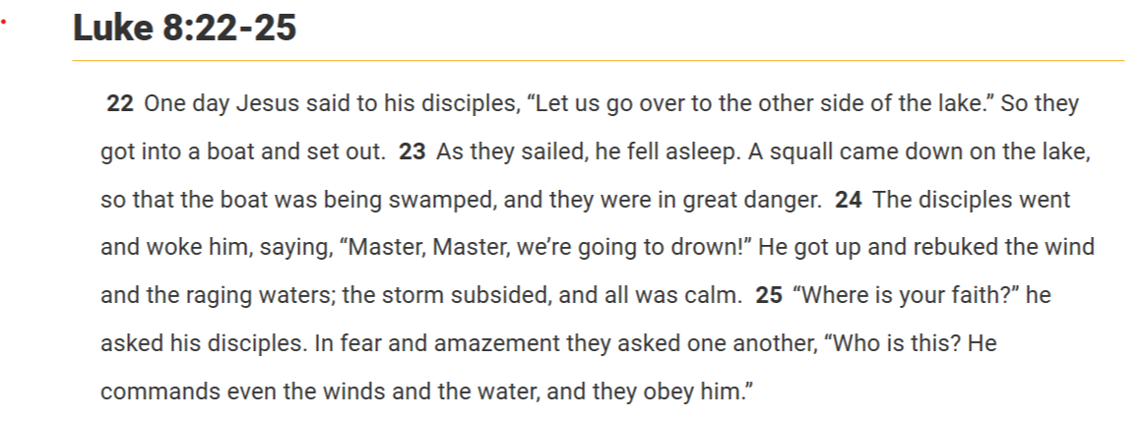

**Activity 4:**

Create a cartoon strip to show your understanding of the story of Jesus calming the storm.