Woodpecker Class Suggested Home Learning Daily Timetable
Remember to keep hydrated and take plenty of brain breaks
Activity 1 | Activity 2 | Activity 3 | Activity 4 | Activity 5 | Activity 6 | Activity 7
Collective worship | Exercise | Maths | English | Reading | Creative Tasks | Story time with Mrs Irvine
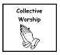 | 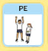 | 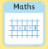 |    | 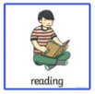 |   Can be:  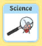   | 
Please follow the following links to help you with your learning:
Collective Worship: https://www.archbishopcourtenay.org.uk/prayer-for-the-day/
PE with Joe Wicks: https://www.youtube.com/watch?v=f1DCBvypjNw
Maths year 3: https://whiterosemaths.com/homelearning/year-3/
English/History: Check your class pages for the weekly timetable and activities
Creative curriculum: Check your class pages for the weekly timetable and activities
Storytime with Mrs Irvine: https://www.archbishopcourtenay.org.uk/english-27/ each chapter has its own star.

