Text: | Viking Boy by Tony Bradman  Chapter 1 Men’s Work
Reading age | Year 3 and 4
Pre reading | - Have you read any other books by this author?  - Look at the cover. What do you think the story will be about?  - What sort of story do you think it is?  - Look at the synopsis (blurb). What does that tell you about the book?  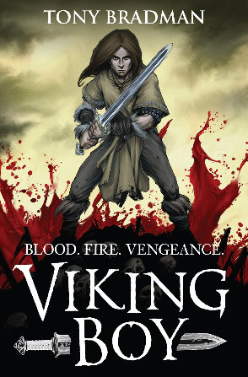  Gunnar is the son of a Viking chieftain, living peacefully on the family steading – until they are raided by the Wolf Men, who raze his home to the ground. Gunnar swears an oath of vengeance against his enemy – but first he must run to save himself.
Difficult words | - colossal, shimmering, caper, rhythmic, steading, scabbard, pommel, stout, banter, indulge
Reading and responding to text | - Where do you think the story is set?  - Do you think this story is set in the past or present?  - Find some similes and metaphors in this chapter.
Follow up independent work before next session | - From the description of the inside of the house on p 12 and 14, draw a picture and label it.  - What do you think might happen next? Justify your answer.  - Find some words and phrases in the text to show how the characters’ feelings change when they see the riders arriving.  - Make a list of the main points of the text so far.  - Difficult words for next time – find meaning of any you don’t understand: tendrils, slaughter, jerkins, notched, underscore, acrid, anguished

