R9a. Can make accurate and appropriate comparisons within texts
Skills Test 1

Commissioned by The PiXL Club Ltd.
August 2018
This resource is strictly for the use of member schools for as long as they remain members of The PiXL Club. It may not be copied, sold nor transferred to a third party or used by the school after membership ceases. Until such time it may be freely used within the member school.
All opinions and contributions are those of the authors. The contents of this resource are not connected with nor endorsed by any other company, organisation or institution.
PiXL Club Ltd endeavour to trace and contact copyright owners. If there are any inadvertent omissions or errors in the acknowledgements or usage, this is unintended and PiXL will remedy these on written notification.

© Copyright The PiXL Club Limited, 2018

9a. Can make accurate and appropriate comparisons within texts
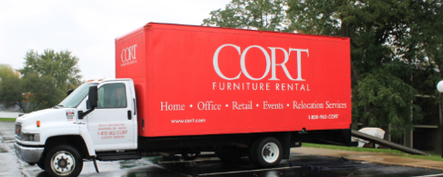
Read the text and answer the questions below. Use the spaces provided to write your answers or put a tick or number in the correct box.
Moving Day
The first thing that Sophie did when they arrived at their new accommodation was to look out of the window. The ride in the filthy, smelly lift had seemed to have taken for ever; now she could see just how high up they were. Tiny cars scurried along the roads like rats along a sewer. Tower blocks, factories and street after street of tightly-packed houses clogged the near and middle distance. Peering through the yellowy-brown haze that suffocated the city, she could just about pick out the leafy parks and avenues of where they used to live – salt in the wound. She could still smell the freshly cut grass and the nodding pink roses that she had planted herself. She imagined herself to be outside, running through the greenery, the birds singing and the trees swaying. There, she didn’t have to ride in a lift to get to her front door; she lived in a proper house. There, she just walked up the tiled front path to the familiar black front door and went straight in. The view from the window at home (for she was determined that there would always be home and here would never be) was of park and grass and hedgerows and woodland, not grey dreary roads and buildings. She sighed sadly.

- How is where Sophie has moved to now different to where she lived before? Give three points. Use evidence from the text to support your answer.
________________________________________________________________________

________________________________________________________________________

________________________________________________________________________

________________________________________________________________________

________________________________________________________________________

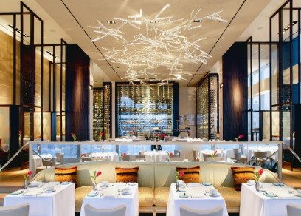
The Restaurant
Bethany’s stomach was rumbling. Here she was, sitting in this brand-new, classy restaurant that everyone had said was so marvellous, and yet no one had even come over to her table to take her order. Her heart sank. She had had such high hopes for today and she had been saving for what felt like forever to eat at the restaurant everyone had been raving about.
“The food is to die for,” they had all said.
“And as for the service, it’s incredible – friendly, efficient and super-fast.”
They had also said that the atmosphere was like nothing they had experienced before and the live music was the talk of the town because it was so lively and entertaining. Well, the atmosphere so far had been stuffy and boring. There was no music playing and all she could hear was the drone of the air conditioning unit.
Bethany sighed. Not wanting to embarrass herself, she sat quietly, hoping to catch the eye of one of the waiters. No such luck. They all seemed to be too busy bursting in and out of the doors to the kitchen, or talking to customers who had already been served. Worse still, she could hear them exaggerating their fake foreign accents in a desperate attempt to impress the customers. Bethany looked around at the shiny, polished room; she could see other people becoming agitated as they had been waiting as long as, or longer than, she had. At least she wasn’t the only one. She was beginning to think that everyone had got it wrong and the restaurant was not so marvellous after all. Bethany knew that in life things often didn’t live up to expectations.

- What is the difference between what Bethany expected the restaurant to be like and what she actually experienced? Give two points.

- ________________________________________________________________

________________________________________________________________

- ________________________________________________________________

________________________________________________________________

9a. Can make accurate and appropriate comparisons within texts
Answers:
- Accept any comparative statements which show the difference between old and new. For example:
    - Her new house is in a block of flats and her old home was a house.
    - The view is of buildings and roads and in her old house it was park and grass, hedgerows and woodland.
    - In her new house, she must use a lift to get to her front door but in her old house, she just walked up the tiled path and went straight in.

- Accept any comparative statements which show the difference between what she expected and what she actually experienced. For example:
    - She expected the service to be friendly and efficient, but it took her a long time to get served and the waiters were talking to others/exaggerating fake foreign accents.
    - The atmosphere was supposed to be like nothing she had ever experienced before, but instead it was stuffy and boring.
    - She expected live music but all she could hear was the air conditioning.

