Design and Technology

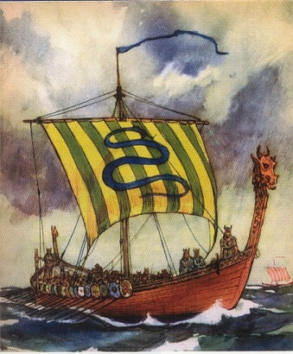

Making and designing

Viking boats

Name:_________________

Research

Skill: I can collect information about Viking boats.

What were they made of?

How big were they?

How did they move?

What were they used for?

What characteristics would the boat need to have?

Draw and label a Viking boat

Design

Skill: I recognise that my designs have to meet a range of different needs.

What is your design brief?

What are your specifications?

Initial ideas

Skill: I communicate my ideas

Firstly, you need to think about the design of your dragon head and tail. Sketch 2 designs.

Head Tail

|  |  |
| --- | --- |
|  |  |

|  |  |
| --- | --- |
|  |  |

How will you make sure that the dragons head is detachable?

Now you need to design your sail. Sails were usually plain or striped. Try to design your sail to reflect your personality. Sketch 2 designs.

|  |  |
| --- | --- |
|  |  |

Sketch 3 shields for your boat. Shields were circular and brightly coloured.

|  |  |  |
| --- | --- | --- |
|  |  |  |

How will you make the steering paddle move up and down?

Final Designs

Skill: I communicate my ideas using words and labelled sketches, showing that I am aware of the constraints of my design.

*Draw, label and colour your final designs.*

Final design for the dragon head and tail.

Head Tail

|  |  |
| --- | --- |
|  |  |

Final design for the sail.

Final design for the shields.

How will you decorate your boat?

Final design

Sequence of work

Skill: I think ahead about the order of my work, choosing appropriate tools, equipment, materials, components and techniques.

Materials/ equipment needed:

Step-by-step process to make your Viking boat.

Evaluating

Skill: I recognise what I have done well in my work. I suggest things I could do in the future.

What are the strengths of your boats?

If you made a boat again in the future, what improvements would you make?

Did you meet the design brief?

Did you change anything from your original plan?

Are you pleased with your final product?

Finally…

Vikings named their ships. For example, “Long Serpent” and “Snake of the sea.” Give a name to your boat: