Anderson Shelters

In November 1938, Prime Minister Neville Chamberlain placed Sir John Anderson in charge of Air Raid Precautions (ARP). He immediately asked an engineer, Williams Patterson, to design a small cheap shelter that could be put up in people’s gardens.

Within a few months nearly one and a half million of what became known as Anderson Shelters were distributed to people living in areas expected to be bombed by the Luftwaffe. The first one was build in 1939 in a garden in Islington, London on 25th February.

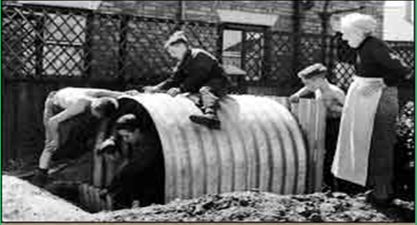

Anderson Shelters were made from six curved sheets bolted together at the top, with steel plates at either end. They were 6ft 6in by 4ft 6in (1.95m by 1.35m) and could accommodate six people.

These shelters were half buried in the ground in gardens with earth heaped in top to keep them secure. The entrance was protected by a steel shield and an earthen blast wall.

They were incredibly **strong**. They were especially strong against a compressive force – for example the explosion of a nearly bomb – because of their corrugation.

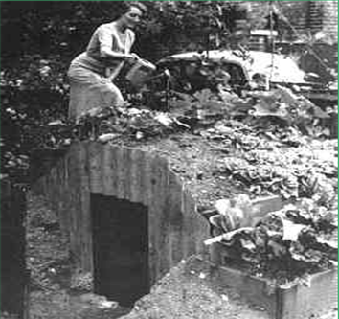

Anderson shelters were given free to poor people. Men who earned more than £5 a week could buy one for £7. Soon after the outbreak of the Second World War in September 1939, over 2 million families had shelters in their garden. BY the time of the Blitz this has risen to two and a quarter million.

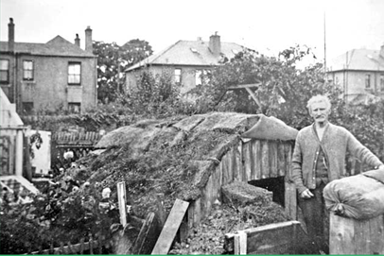

Anderson Shelters were covered with soil. People grew flowers and vegetables on top to try and brighten them up!

27% of people used Anderson Shelters, 9% slept in public shelters and 4% in the underground, others didn’t shelter at all!

When the Luftwaffe changed from daylight to night bombing raids, the government expected people to sleep in their Anderson Shelters.

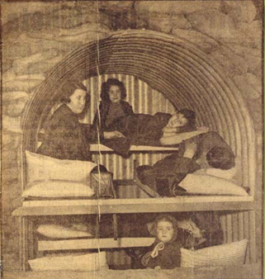Anderson Shelters were dark and damp and people were reluctant to use them at night. In low-lying areas, they tended to flood and sleeping was difficult as they did not keep the sound of bombings (Unlike the underground where you could not her the bombs). If you were over 6ft tall it was incredible difficult to fit comfortably inside.

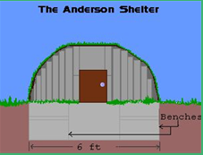

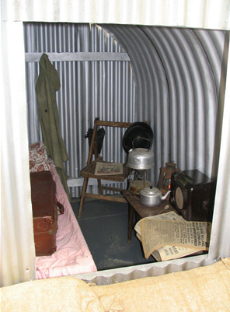

Inside their shelter, many families kept games, books and biscuits and bottled drink.

Some people had small cookers and electric toasters in their shelters.

