Design and Technology
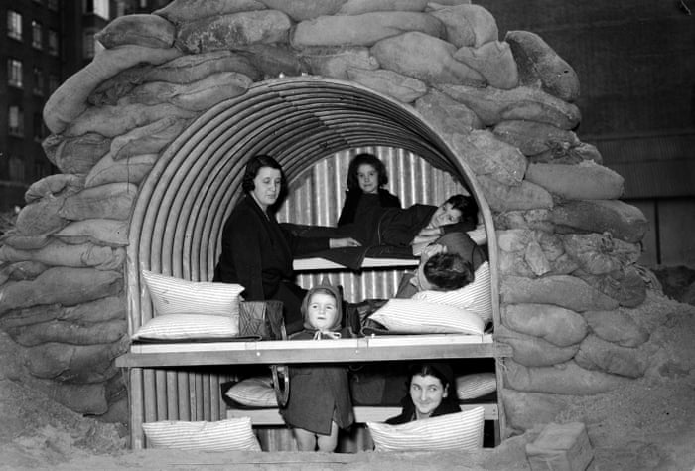
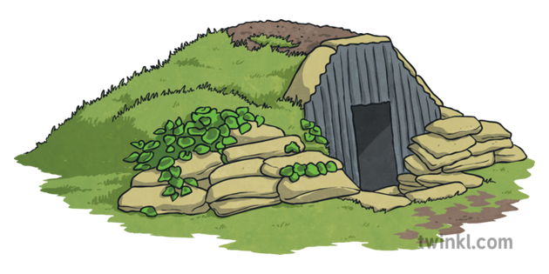Making and designing
Anderson Shelter

Name:_________________
Research
Skill: I can collect information about Anderson Shelters.

Who created them? When were they created?

What was the purpose of them?

What were they made out of?

How big were they? Where would they be built?

What was in them? How many people could fit in them?

Were they a nice place stay in? Why?

v
Who had them? How much were they?

What characteristics would the shelter need to have? (What did they need o be able to do?

Draw and label an Anderson Shelter

Strength Testing - Shape
To inform your design, complete the test below.
Anderson Shelters: Strength

Take a single piece of paper.

Your challenge is to make a bridge to cross a 15cm gap, using just a single piece of paper, which is as strong as possible.

Use small items available to test how strong your bridge is.

Try lots of different designs and think about how you can change the shape of the paper using different folds.

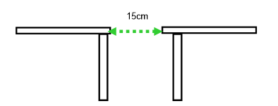

Testing – Materials
To inform your design, complete the test below using different materials from around you house. The aim is to find the best material for the task at hand!
Use full sentences for your answers and not just one word answers.

The last part is very important as it will help you design your
shelter.
What recycled material are you testing?
How easy is it to cut into a circle?
How easy is it to fold into a different shape?
How string it is? How much force does it take to rip?
Is this material a good choice for your Anderson Shelter? Why? Which part will you use it for?

Testing – Material Strength
To inform your design, complete the test below using different materials from around your house to see the strongest. You can use items in your house to test the materials strength, for example, tins of food or books.

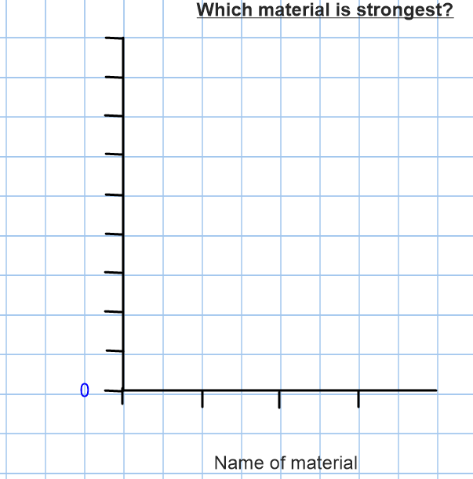

Design
Skill: I recognise that my designs have to meet a range of different needs.
What does you design need to be able to do to be realistic?

What materials could give you the ability to meet the needs of its design? E.g. would cling film work for the roof?

Initial ideas
Skill: I communicate my ideas
Firstly, you need to think about the materials needs for each part of the Shelter.

Part of the Shelter | Materials that could be used
Floor
Sides
Roof
Protection outside
Any resources inside?

Final Designs
Skill: I communicate my ideas using words and labelled sketches, showing that I am aware of the constraints of my design.
Final design for the Anderson Shelter. Label with the materials you are going to use.

Sequence of work
Skill: I think ahead about the order of my work, choosing appropriate tools, equipment, materials, components and techniques.

Materials/ equipment needed:

Step-by-step process to make your Anderson Shelter.

Evaluating
Skill: I recognise what I have done well in my work. I suggest things I could do in the future.

Does your Anderson Shelter hold weight? How much weight?

Is there enough space inside for humans to live? (to scale; can use lego figures or similar to test)

What are the strengths of your Anderson Shelter?

If you made a Anderson Shelter again in the future, what improvements would you make?

Did you change anything from your original plan?

Are you pleased with your final product?

