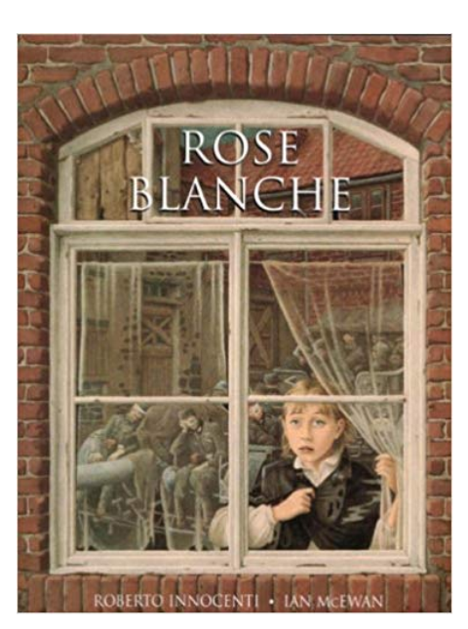
Lesson 1 (page 1 - 3)
Look at the front cover of the book.
- What might this book be about? Predict and infer using the front cover.
- What can the little girl see out of the window?
- What questions do you have about the book from the front cover?
- The title has a double meaning: research the words. I wonder why the author has chosen this.

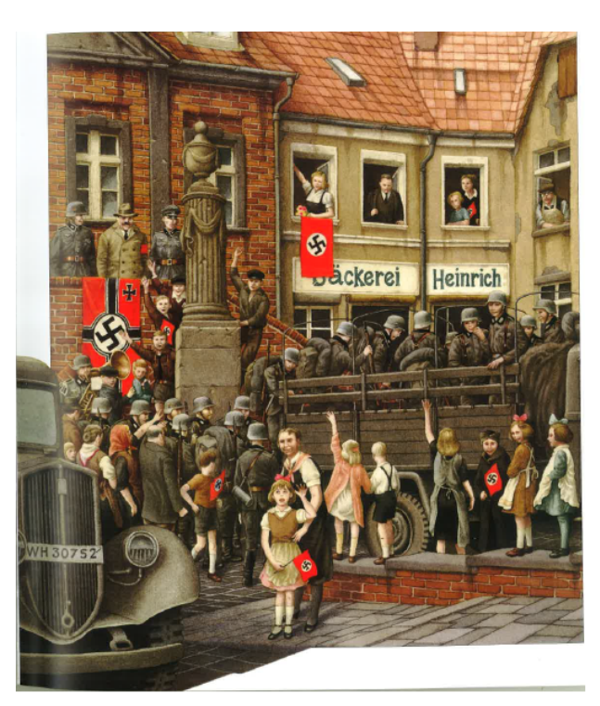
Look at the second picture. Does this add to your thinking?
- What do you think is happening in this picture?
- Infer and predict from the image what you think is going to happen in the book.

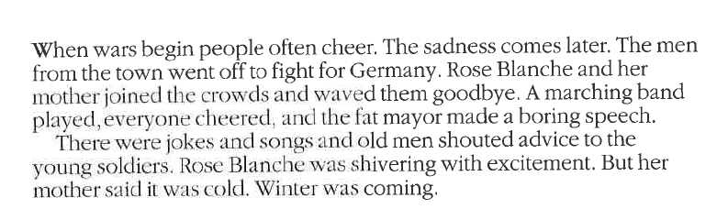

- When wars begin people often cheer. Why do you think people often feel positive at the start of war?
- How are cheerful people depicted in the illustration?
- Where is the mayor? Why do you think he is there? What does it symbolise?
- Why do you think Rose shivered?
- Look carefully at the colours the authors used, why do you think he did this?

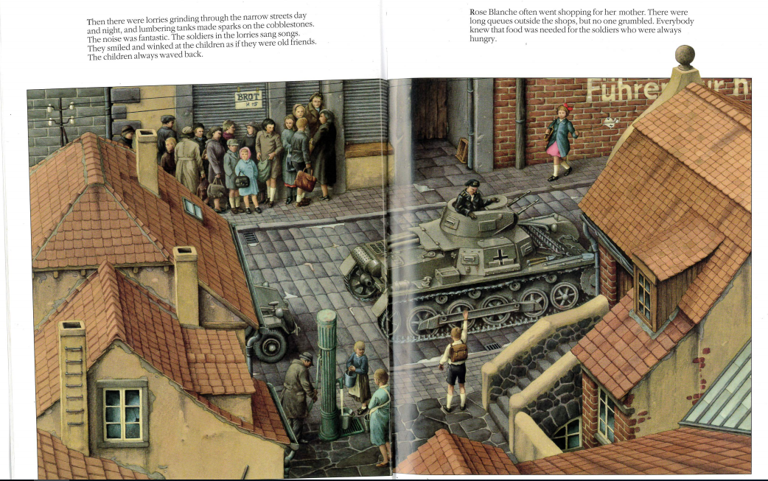

- What is the overall mood of this page? Use clues from the text and also the picture to support your answer.
- There were long queues outside the shops but no one grumbled. Why do you think that people didn’t complain?
- Look at the boy waving at the tank: what might he be saying?
- Take note of the descriptive language used in the first paragraph. Change the descriptive language to make a new paragraph with the new words you have chosen. E.g. ‘…lorries grinding through the narrow streets…’ = ‘…lorries scraping through the tapered streets…’

Lesson 2 (page 4 - 9)
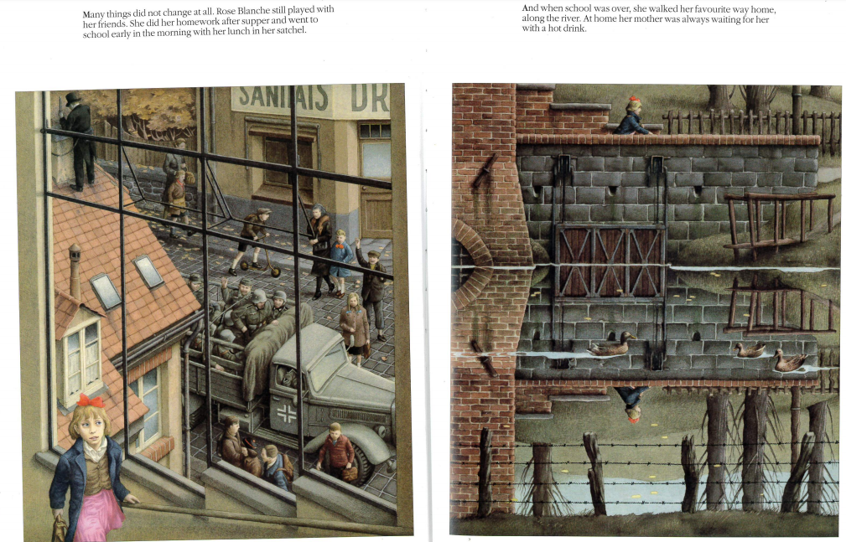

- What things stayed the same? What things might have changed?
- What is clever about the second picture?
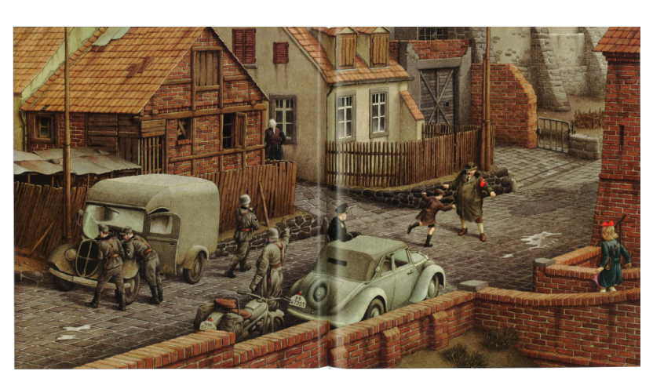

B
A
C

- What can you see happening?
- Write speech/thought bubbles for characters labelled A, B and C in the picture according to what you think is happening.

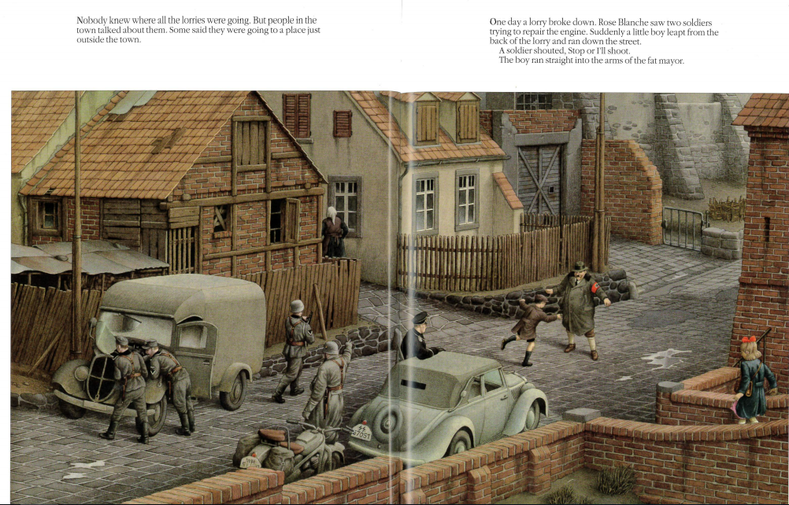
- Where do you think the lorries were going?
- What do the words ‘leapt from the lorry’ tell you?
- Now you have the words to go with the illustration, what is Rose thinking?
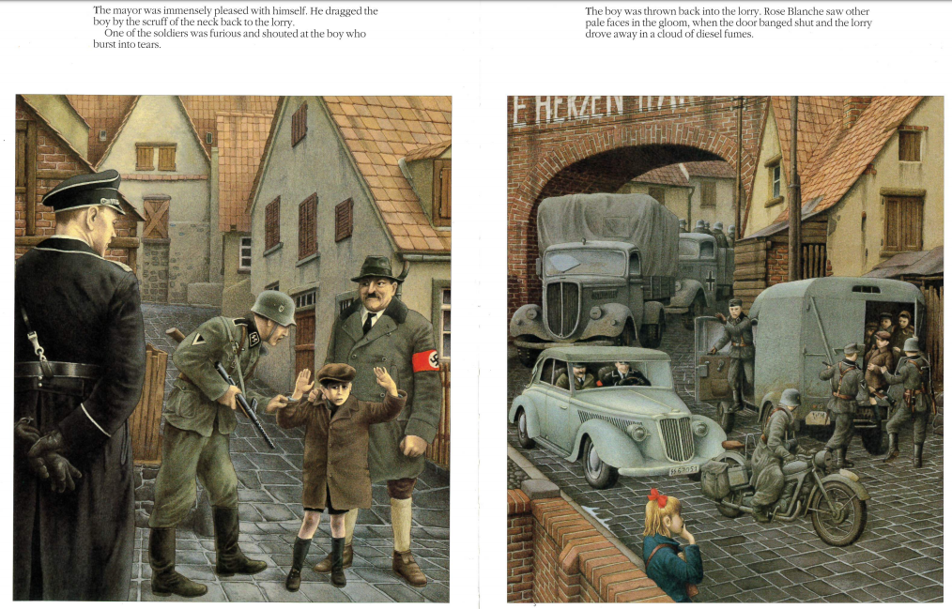
- Compare and contrast how the 3 characters are feeling and why. Use the table below to help with your explanation. Use evidence from the text.
 | Mayor | Boy | Rose
Feelings

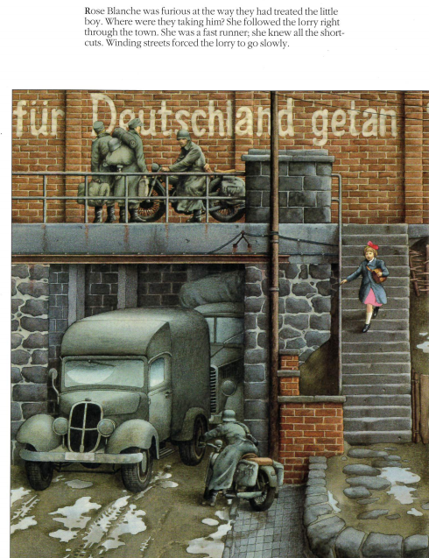
Lesson 3 (pages 10 - 15)

- How did Rose keep up with the lorry?
- Why did she follow the lorry? Use evidence from the text.

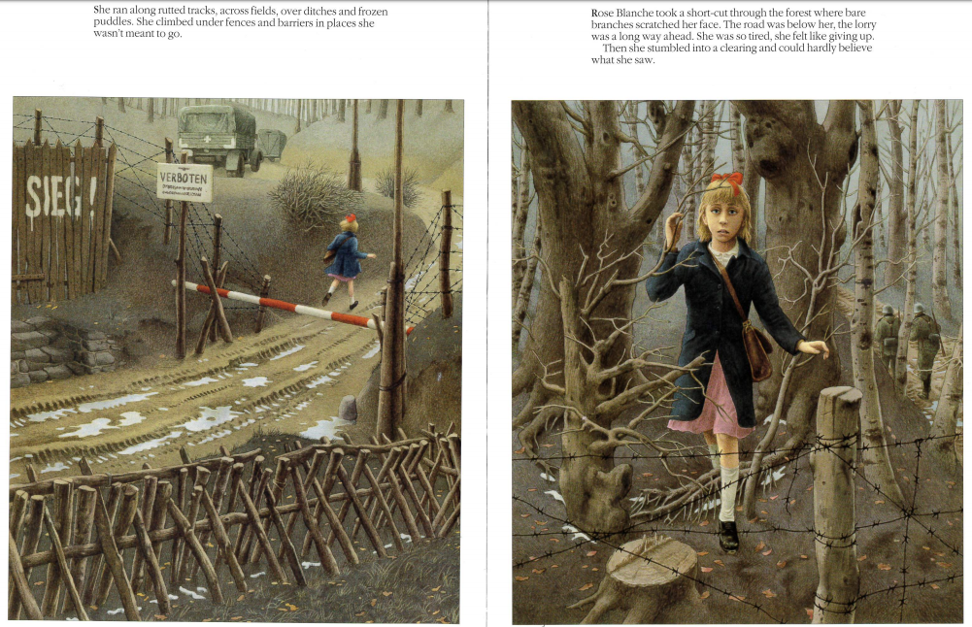
- Research what the words ‘Sieg’ and ‘Verboten’ mean. What could these words suggest about what Rose might encounter?
- What does the phrase ‘she was so tired she almost felt like giving up’ tell us about Rose’s character?
- What do you think Rose can see ahead?
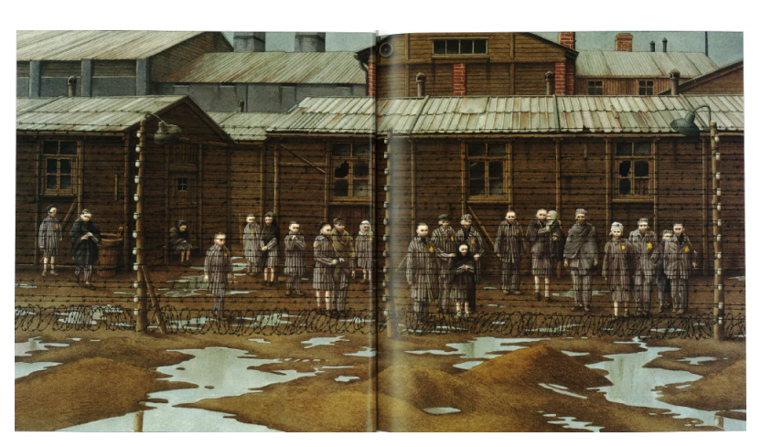

- What could Rose see?
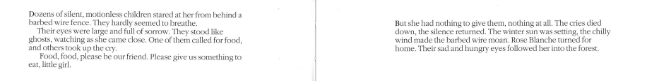
- Why was she startled?
- What does the phrase ‘their sad and hungry eyes followed her’ mean?
- What does the phrase ‘the barbed wire moaned’ mean? What literary device has the author used?
- How do these children feel? Provide evidence for your answer.

Lesson 4 (pages 16 – 21)
- Sequence the events from the book in the correct order.
- Soldiers went away
- A truck broke down
- Rose became suspicious
- Rose followed the truck
- War began
- Trucks started arriving
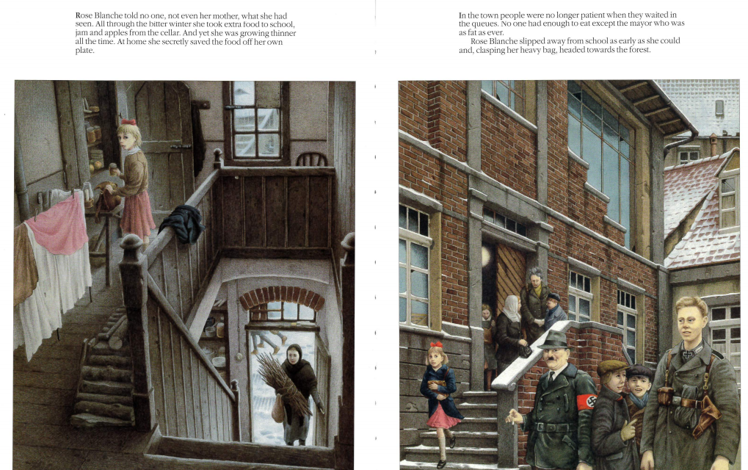
- Rose was startled

- Why do you think Rose didn’t tell her mother?
- What does the phrase ‘growing thinner’ mean?
- What does the word ‘clasping’ mean? Why was she clasping the bag?
- If you were in Rose’s shoes, what would you do? Explain your reasoning.

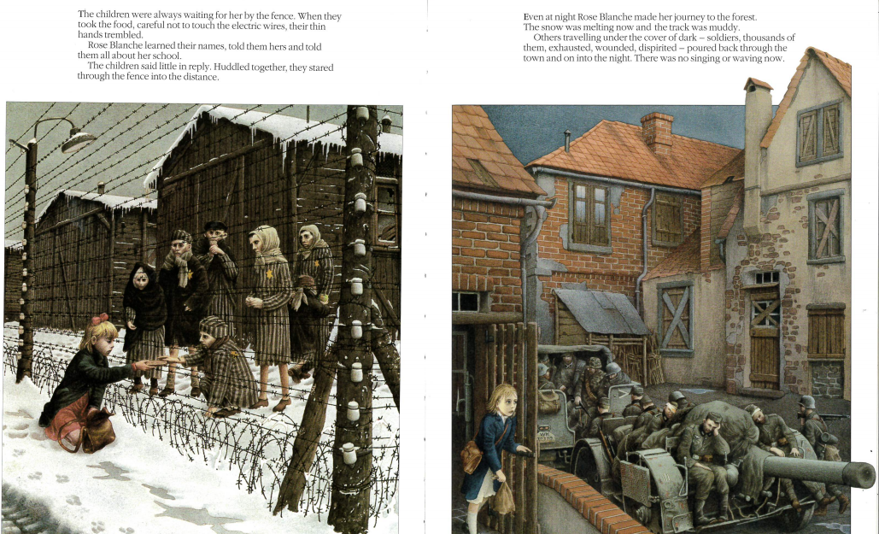
- What evidence is there is suggest Rose has been to see the children more than once?
- How do you think the children feel about Rose bringing them food?
- Soldiers have come back to the town ‘exhausted, wounded, dispirited’. What do you think has happened? What other evidence is there in the text to back up your ideas?
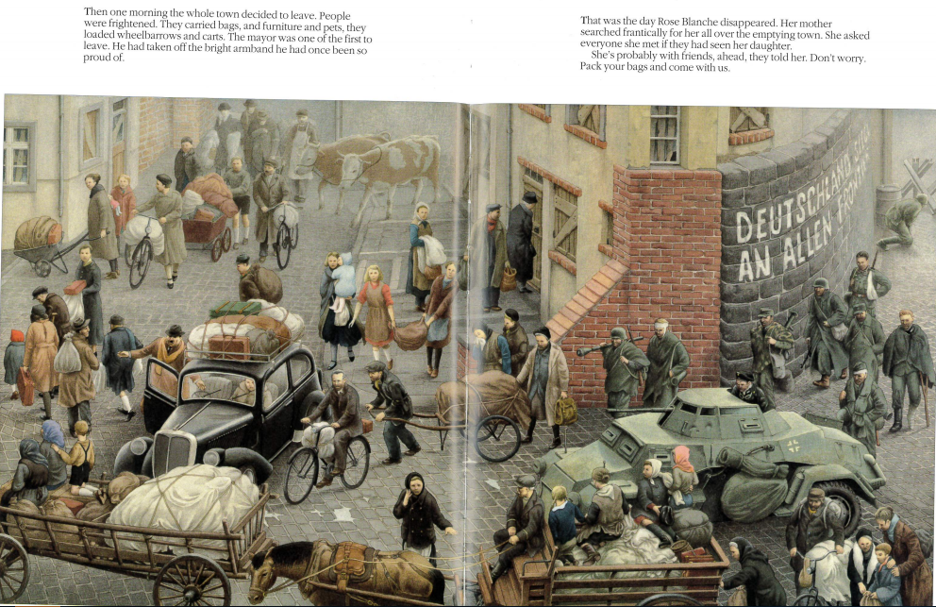
- Why are people leaving?
- Where is Rose?

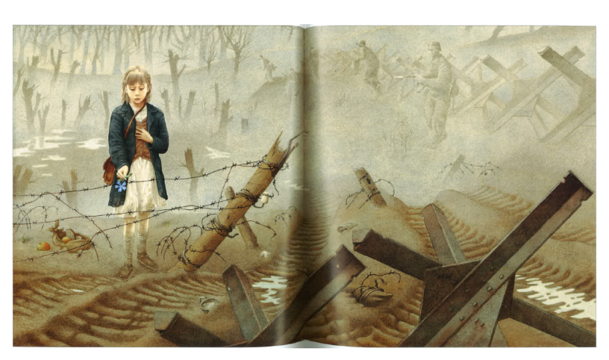
Lesson 5 (pages 22 - 27)
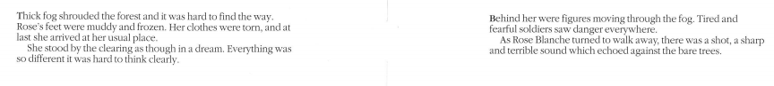
- What is happening in this picture? Predict what might happen.
- What is different about Rose in this picture compared to the others pictures of her from pages 1 – 18?
- Why to do think the author/illustrator has done this?

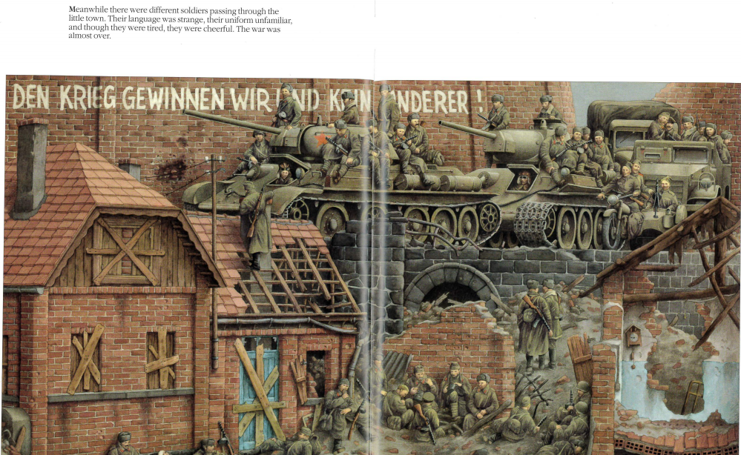
- What can you infer from this paragraph and image?
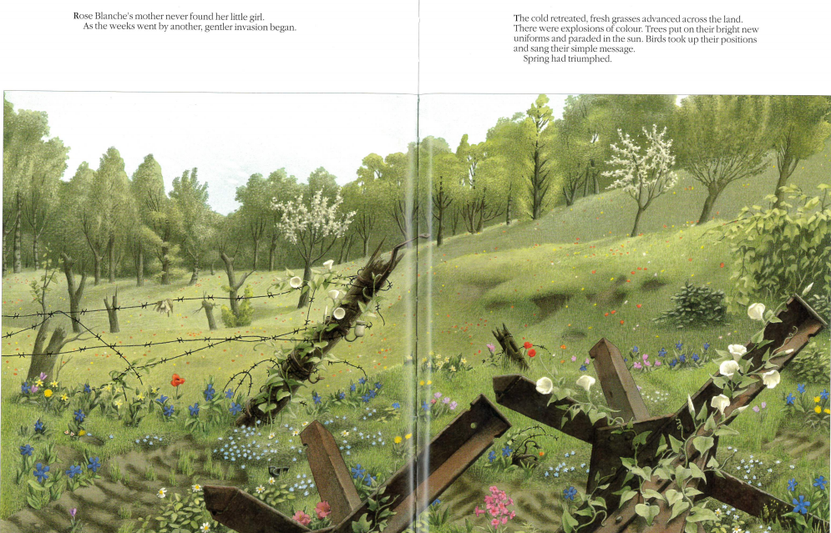
- What do you think happened to Rose? Why?
- What is the ‘gentler invasion’ in line 2?
- Why were there ‘explosions of colour’?
- Why does the author use the seasons winter and spring for the story?
- What do you think the message of the book is?

