# **R2b. Can find and copy one word/groups of words with a particular meaning**

# **Skills Test 1**

**Commissioned by The PiXL Club Ltd.**

**August 2018**

**This resource is strictly for the use of member schools for as long as they remain members of The PiXL Club. It may not be copied, sold nor transferred to a third party or used by the school after membership ceases. Until such time it may be freely used within the member school.**

**All opinions and contributions are those of the authors. The contents of this resource are not connected with nor endorsed by any other company, organisation or institution.**

**PiXL Club Ltd endeavour to trace and contact copyright owners. If there are any inadvertent omissions or errors in the acknowledgements or usage, this is unintended and PiXL will remedy these on written notification.**

© Copyright The PiXL Club Limited, 2018

**2b. Can find and copy one word/groups of words with a particular meaning – Test 1**

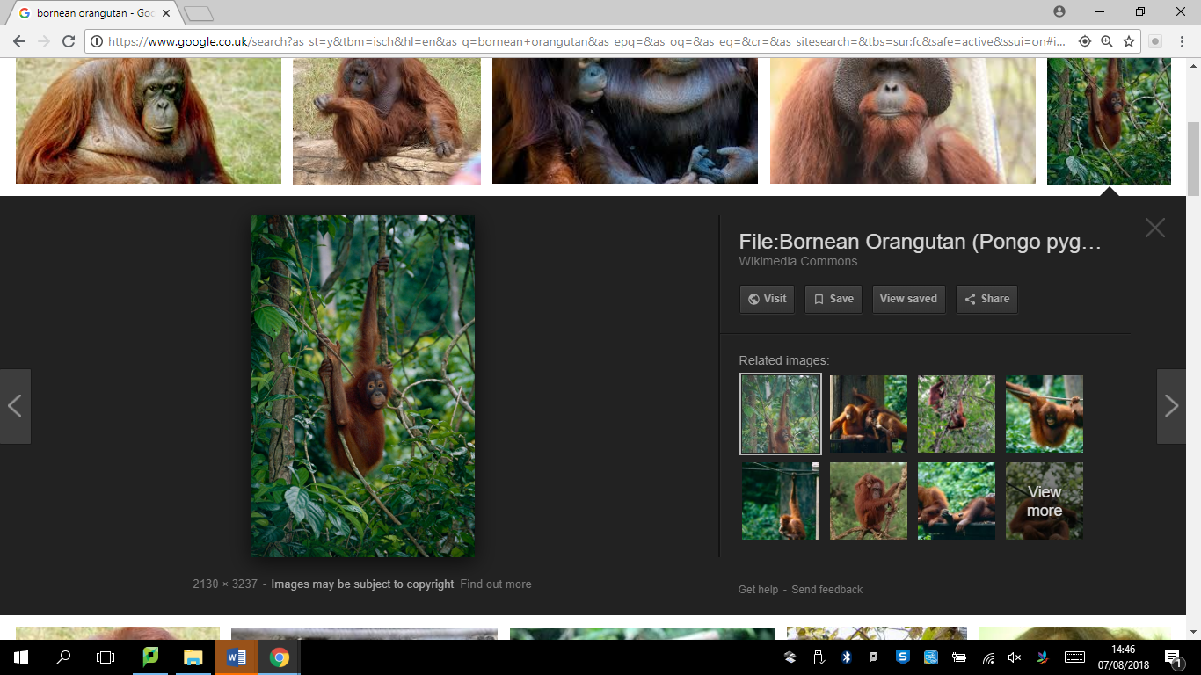*Read the text and answer the questions below. Use the spaces provided to write your answers.*

**Bornean Orangutans**

The Bornean Orangutan is now critically endangered. Their populations are in decline thanks to rapid deforestation and devastation of their habitats, as well as illegal hunting.

Bornean Orangutans are unique to the island of Borneo. The word orangutan translates to ‘man of the forest’ in Malay language. Orangutans reside in the rain forest and their bodies are well-designed for climbing trees, with extended arms and powerful hands and feet for gripping the branches.

Orangutans are the only great ape to travel predominantly through trees, spending nearly their entire existence in trees, swinging through the canopies and constructing nests for sleep. Orangutans are *arboreal,* as large predators (such as tigers and leopards) patrol the forest floor.

Fruit, such as lychees, mangoes and figs, makes up sixty per cent of an orangutan’s diet. Orangutans also eat leaves and shoots, insects, soil, tree bark and occasionally eggs and small vertebrates.

1. In the first paragraph: **find** and **copy one** word meaning *at risk.*

___________________________________

1. **Find** and **copy** a group of words that means that the number of Bornean Orangutans is decreasing.

__________________________________________________________________

1. **Find** and **copy one** wordfrom the second paragraph meaning *one of a kind.*

____________________________________

1. In the paragraph beginning *‘Bornean Orangutans …’* **find** and **copy one** word meaning *live.*

_____________________________________

1. **Find** and **copy** a group of words that means the same as *almost their whole life*.

__________________________________________________________________

**2b. Can find and copy one word/group of words with a particular meaning – Test 1**

**Answers:**

1. endangered
2. (Their) populations are in decline
3. unique
4. reside
5. nearly their entire existence