# **R2c. Can find words in a text that most closely match the meaning of a given word**

# **Test 1**

**Commissioned by The PiXL Club Ltd.**

**August 2018**

**This resource is strictly for the use of member schools for as long as they remain members of The PiXL Club. It may not be copied, sold nor transferred to a third party or used by the school after membership ceases. Until such time it may be freely used within the member school.**

**All opinions and contributions are those of the authors. The contents of this resource are not connected with nor endorsed by any other company, organisation or institution.**

**PiXL Club Ltd endeavour to trace and contact copyright owners. If there are any inadvertent omissions or errors in the acknowledgements or usage, this is unintended and PiXL will remedy these on written notification.**

© Copyright The PiXL Club Limited, 2018

**2c. Can find words in a text that most closely match the meaning of a given word – Test 1**

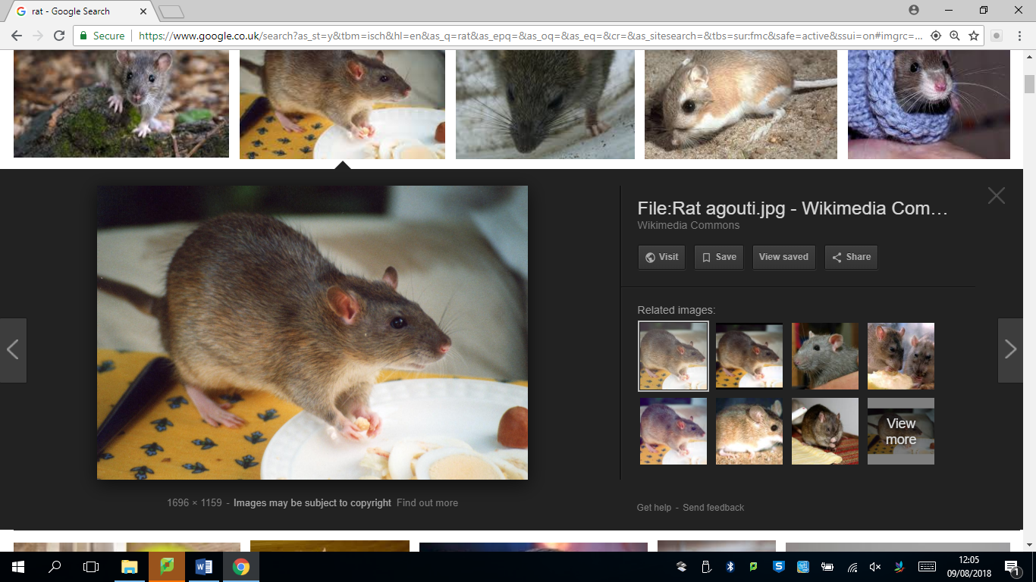*Read the text and answer the questions below. Use the spaces provided to write your answers or put a tick in the correct box.*

**The New House**

The new house was condemned from day one. We had not been there a whole day when my brother Kadeem tripped on a protruding nail and toppled down the stairs, knocking himself unconscious. The upstairs shower (when not spewing out dust) leaked and caused the bathroom floor to bow as well as water damage in the front hallway. The wiring was in such a state of disrepair that every time we turned something on there were blue sparks and a strange burning smell.

The rats were the final straw. Kadeem had located their nest beneath one of the unsecured (and now wet and rotting) floorboards in the main bathroom. He yelled for mum, who tried to lure them out with some seriously pongy cheddar. It was an ingenious plan, except that it didn’t work. So, my father, in all of his wisdom, decided to nail all of the floorboards down to prevent them from escaping.

That evening, Kadeem and I could not sleep. Kadeem, out of bed at this point, paced the floor restlessly. Something was keeping us awake, but we could not put our finger on it. Then we heard it, the scratching sound.

“Fiza,” Kadeem whispered. “Do you hear something?”

I did – and the noise was amplifying. Scratching and scraping filled the air, resonating around the room. It appeared to be coming from beneath us. And then … pandemonium! The floor started rattling, floorboards started pinging up, nails were flying and wood splintering.

1. Look at the first paragraph. Which word is closest in meaning to *sticking out*?

­­­­­­­­­­­­­­­­­­_____________________________________

1. Look at the paragraph beginning: *‘The rats were …’.*

Which word is closest in meaning to the word *found*?

_____________________________________

1. *‘… beneath one of the* ***unsecured*** *(and now wet and rotting) floorboards.’*

Which word is closest in meaning to the word *unsecured*?

Tick **one**

rotten

sturdy

loose

dangerous

1. In the second paragraph, the word ‘*lure’* is closest in meaning to:

Tick **one**

trap

tempt

secure

pull

1. In the final paragraph, which word means the same as *chaos?*

___________________________________

**2c. Can find words in a text that most closely match the meaning of a given word – Test 1**

**Answers:**

1. protruding
2. located
3. loose
4. tempt
5. pandemonium