Writing Task 2
Today you are going to write David’s diary entry, reflecting on the journey from London to getting into the car with Mr Reynolds.
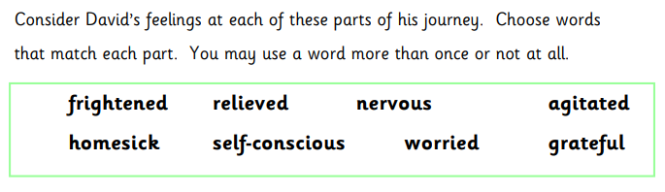
You could use a thesaurus to find additional words and phrases that describe how David is feeling.
