TERM 4 WEEK 2:GEOGRAPHY:
The formation of mountains Factsheets
Use information here to help you complete your diagrams!
Vocabulary

This lesson uses the following geographical terms. These should be used and explained to pupils as the lesson is taught.

Core, mantle, crust These are the main layers of the Earth. These are described in more detail below.
Molten rock Rocks that are in a liquid form.
Viscous Viscosity is a measure of how thick or thin a liquid is. The higher the viscosity, the thicker the liquid; the lower the viscosity, the thinner the liquid. If a liquid is described as viscous it is thick. The mantle is viscous.
Magma Magma is molten rock from the mantle. Magma is within the surface of the Earth. Magma becomes lava only once it flows out over the surface land, for example with a volcanic eruption.
Plates The Earth’s crust is not one solid piece of land, but is formed of many different pieces or plates. There are eight major plates and many more minor plates. These plates move across the mantle.
Plate boundary Where tectonic plates meet.
Plate tectonics This is the theory of the movement of the plates that make up the Earth’s crust.
Convection currents Heat from the Earth is released in currents within the mantle. This is analogous to bubbling porridge in a saucepan. The convention currents within the mantle cause the Earth’s plates to move.
Faults/fault lines These are cracks in the rocks that make up the Earth’s crust. When these are evident blocks of the crust can be forced in different directions- up, down or stacked on top of one another- along the faults. Faults can occur at scales of a few centimetres or, as in the case of fault block mountains, at scales of tens of kilometres.
Converge When two plates move towards each other
Anticlines These are the upward folds of a fold mountain.
Synclines These are the downward folds of a fold mountain.
Erosion/weathering This is the process whereby rocks are worn away through the action of wind and rain. Water can also penetrate rock, and when it freezes in winter, can expand, weaken the rock and lead the rock to crumble.
Rock strata Layers of rock, one above the other, that form the crust rather like the layers in a cake.

The Structure of the Earth
Crust
Mantle
Outer core
Inner core
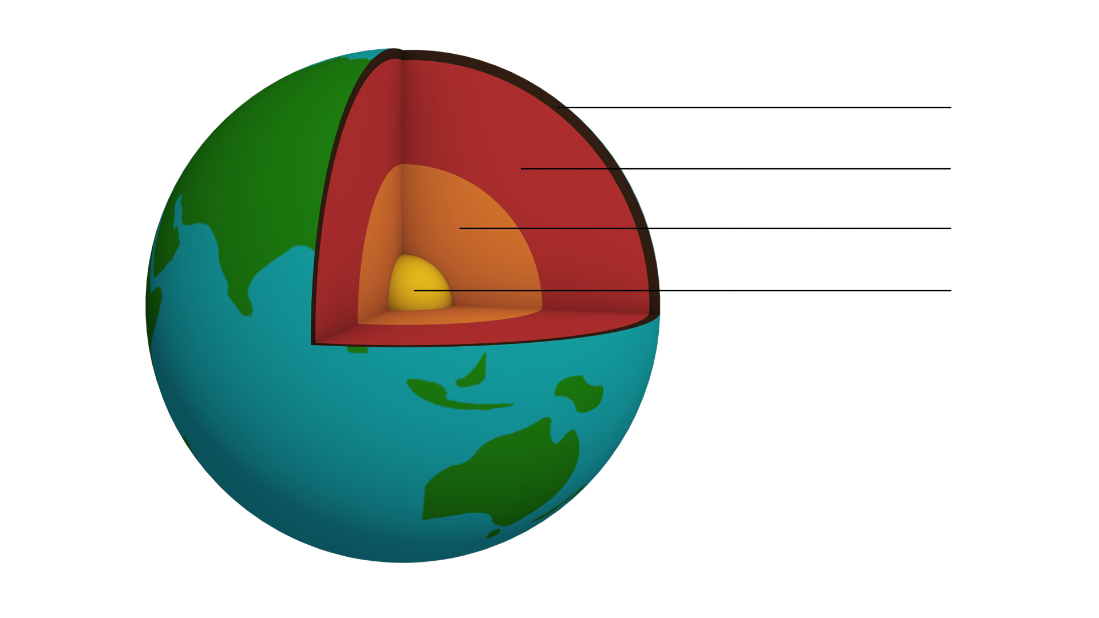

Inner core
The inner core is the centre. It is primarily a solid ball of iron. It has a temperature of 5500^{O}C- almost as hot as the outer layer of the sun, which has a temperature of 6000 ^{O}C. The inner core has a thickness of 1220km. (A distance of 1220km is equivalent to London to Ben Nevis- the UK’s highest peak- and back again). The inner core is solid due to the pressure exerted on it from the other layers.
Outer core
The outer core is composed of iron and nickel. Unlike the inner core, the outer core is liquid. It has a similar temperature to the inner core.
Mantle
This is the thickest part of the Earth, at 2900km. The mantle is viscous and composed of semi-molten rock or magma. A useful analogy is to think of the mantle having the consistency of Blu-tack, not quite a liquid and not quite a solid. It is composed of many different rocks and minerals including iron, magnesium, nickel, silicon and oxygen.
Crust
This is the outer layer of the Earth’s surface. It is the thinnest layer, between 0-60km. It is composed of solid rock and rests on the top layer of the mantle. It is in the crust (and the very upper layer of the mantle) that mountains are formed. When it comes to depth, think of the crust as the skin of a tomato, rather than the peel of an orange.

Plates and Plate Tectonics
The Earth’s surface – the crust- is not one smooth unbroken covering. Rather it is made of different sections called plates (like a cracked egg shell). There are eight major plates: Eurasian, Pacific, Indo-Australian, Antarctic, Nazca, North American, South American and African.
Tectonic plates can be continental (on land) or oceanic (under the sea). For the most part continental plates mark the boundaries of the seven continents (in the case of the North American plate, the South American plate, the Antarctic plate). In other cases the plates include more than one politically defined continent (the Eurasian plate). An example of an oceanic plate is the Nazca.
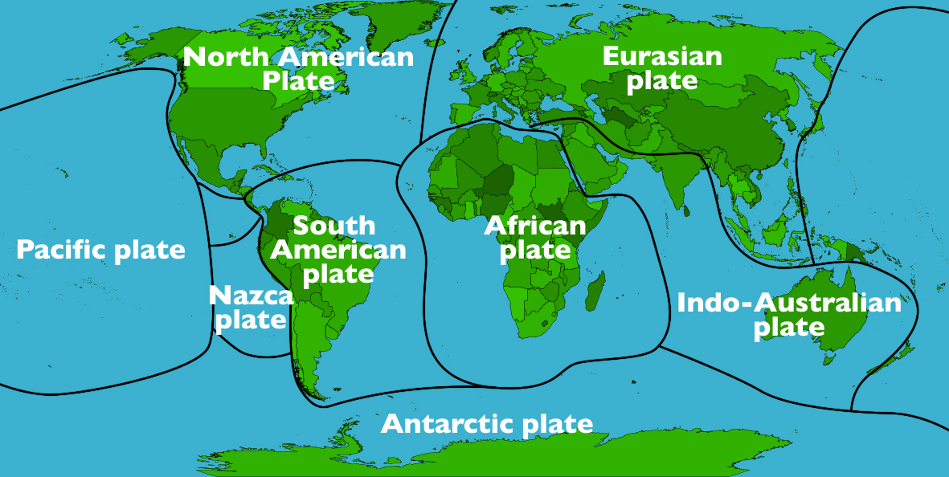
Tectonic plates are pieces of the Earth’s crust and the upper mantle- the lithosphere.
Convection currents
The Earth’s plates are constantly moving; on average, this movement is between 1 and10 cm per year. Convection currents in the mantle cause the plates to move. Heat rises and falls throughout the molten rocks that compose the mantle. As the magma moves, so do the plates above.
Converging Plates
Occasionally two plates move closer to each other, or converge; this creates intense pressure, causing the plates to buckle in different ways. This process forms a mountain.

Fold mountains
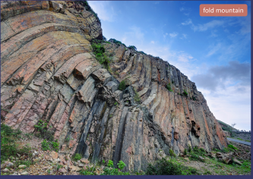
These are the most common type of mountain. As two plates move towards each other they buckle and the crust pushes upwards, forming a mountain. Fold mountains are generally formed between 40-50 million years ago, which is geologically-speaking, young. They are often high with steep faces. Examples of fold mountains include The Himalayas, The Andes, The Rockies and The Alps.
The Himalayas: The Himalayan range was formed 25 million years ago when the Indo-Australian plate collided with the Eurasian plate. Mount Everest, located in the Himalayan range, is a fold mountain and is the highest mountain not only in Asia, but on Earth at 8849 metres above sea level. It is just one of 30 peaks of the Himalayan range. The Himalayan range covers an area of about 594,400 sq km of Pakistan, India, Tibet, Nepal and Bhutan. Everest itself is located on the border of Nepal and Tibet.
.
The upward folds are known as anticlines, and the downward folds are called synclines.
Fault block mountains
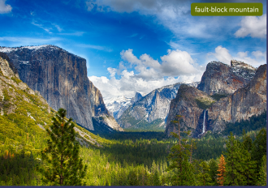
These are formed when two plates move towards each other. Rather than the crust folding under the pressure of the moving plates, it cracks along lines of weakness called fault lines. The crust then breaks into blocks, which are pushed upwards.
The Sierra Nevada: An example of fault block mountains is the Sierra Nevada mountain range in California, USA. The range is located in eastern California and stretches for 640km. The highest peak of the Sierra Nevada is Mount Whitney, at 4418 metres. The mountains are primarily composed of granite. The Sierra Nevada range was the site of the American gold rush in the 1840s.
The block, or section, in between the fault lines can also be pushed down. In this case a rift valley is formed, such as the Great Rift Valley in Kenya.

Dome mountains
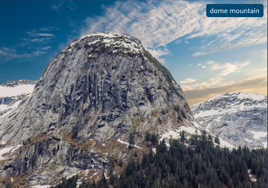
Dome mountains are the result of a great amount of molten rock (magma) pushing its way up under the Earth’s crust. Without actually erupting onto the surface, the magma pushes up the overlaying rock strata which then bulge upwards. Eventually the magma cools and forms hardened rock.
The Black Hills mountain range: An example of a dome mountains is the Black Hills mountain range in South Dakota, USA. The highest peak in the range is Harney peak at 2208 metres. Mount Rushmore, also in the Black Hills, is another example a Dome Mountain, at 1745 metres. It is famous for having the four American presidents, George Washington, Thomas Jefferson, Theodore Roosevelt, and Abraham Lincoln carved into its face. The carving took 14 years and was completed in 1941.

