**History Lesson 2 – The Blitz**

Read the Powerpoint about the Blitz and watch the clip on BBC Bitesize (<https://www.bbc.co.uk/teach/class-clips-video/history-ks2-the-blitz/zm22jhv>) to be able to complete 2 of the 4 activities below.

|  |  |
| --- | --- |
| **Activity** | **How can I do this?** |
| Complete the reading comprehension about the Blitz | Find the reading comprehension sheet on the history page. Read and answer the questions.  Read careful and check your answers. |
| Sketch a scene showing the aftermath of the Blitz. | Use the pictures below to inspire your sketch. Think about what the streets, buildings and people might look like. |
| Recreate being in the Blitz by making an area of your home as dark as possible. | Find a small area of your home and see if you can make it as dark as possible just like in an Air Raid. Think about the resources you have already in your home. Can you use sheets, turn off lights or maybe cardboard to make your area dark?  Remember there weren’t any electrical devices like televisions, iPad, mobile phones or electrical gaming platforms in WW2. How long can you last in your area without any of those gadgets? |
| Create a job advert for an Air raid warden (or similar job). | Think about the new jobs that were created because of the Blitz. Air Raid Wardens, Ambulance drivers and Fire Fighters are just a few. Can you create a job advert to attract people to a role? What qualities do they need to have? You might have to do some extra research for this! |

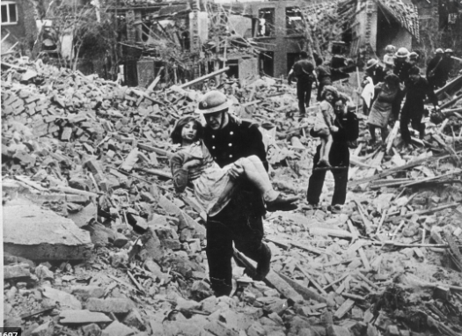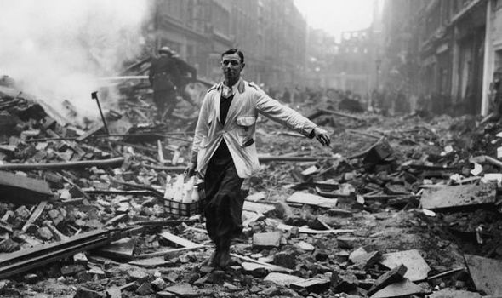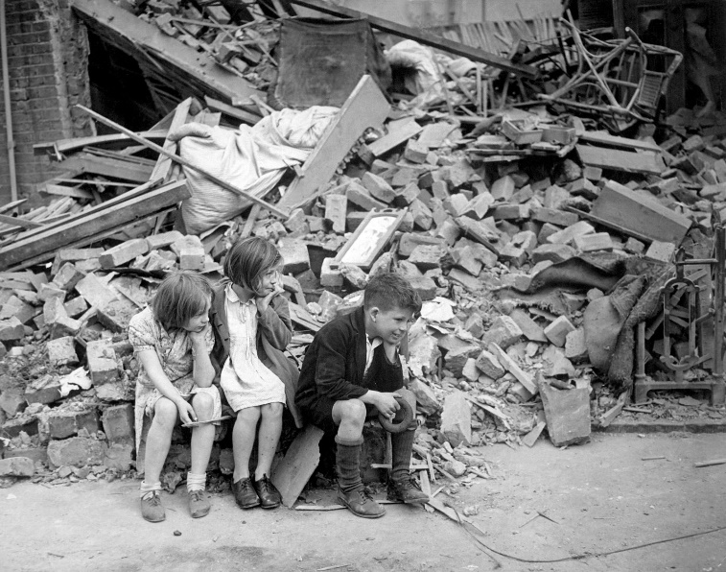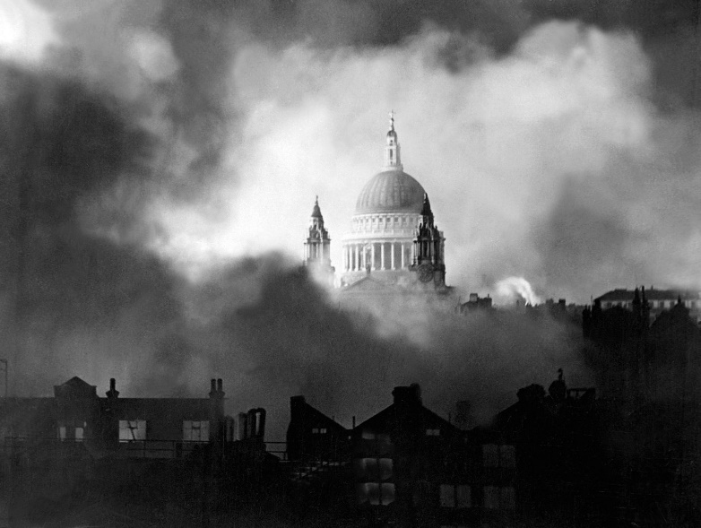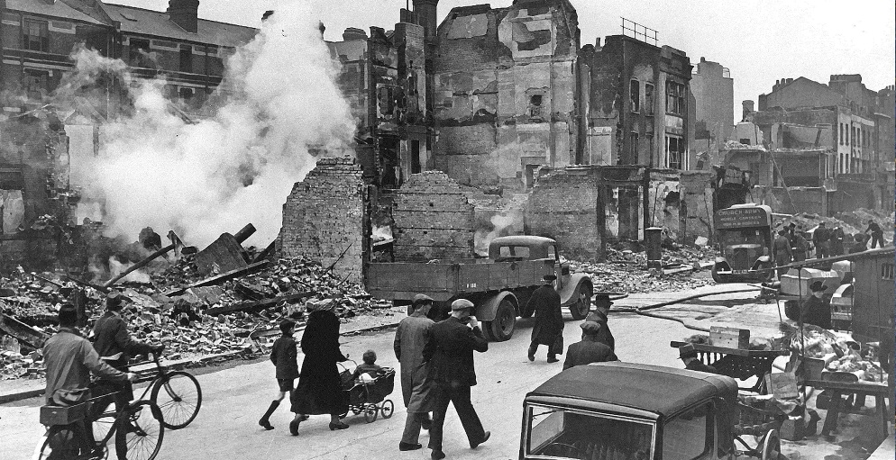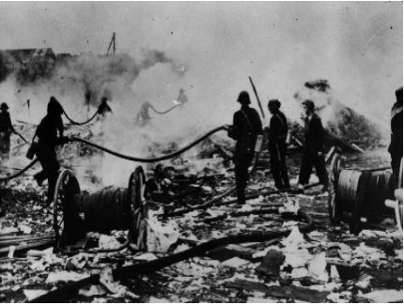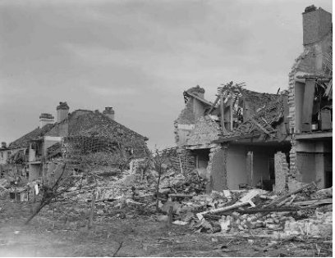**Pictures of the Blitz**