**History/Writing**

Use the evacuees power point to help you with this task.

You will be writing diary entries about your experience as a WW2 evacuee! Use the plan below to structure the 3 days entries you will make. Write notes about your surroundings, feelings and events for each entry. Try to use historic facts to inform your plan and writing.

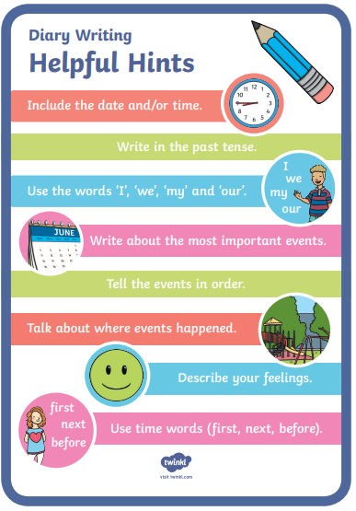Once you have planned it, start your diary entry! Remember these helpful hints about diary writing.

Once written, edit and improve your writing. Look at the editing pages on the class page to help you!

|  |  |  |  |
| --- | --- | --- | --- |
| **Date** | **Describe your surroundings** | **Feelings/Emotions** | **Events that happened on this day.** |
| **1st September 1939**  Being put onto a train. |  |  |  |
| **2nd September 1939**  Meeting host family for the first time. |  |  |  |
| **10th September 1939**  Being with your new family for a week |  |  |  |