
My Favourite Activity



What is it? __________________________________________

What equipment/resources do you need to do it?
___________________________________________________

Who do you do it with? ________________________________

Where do you do it? __________________________________

Why do you enjoy it? __________________________________
____________________________________________________

Are there any rules or instructions? ______________________
____________________________________________________


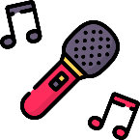
Picture

