**How to complete assignments through Teams**

When your teacher sets you an assignment, you will get a notification through the assignments tab on the left-hand side of the screen. 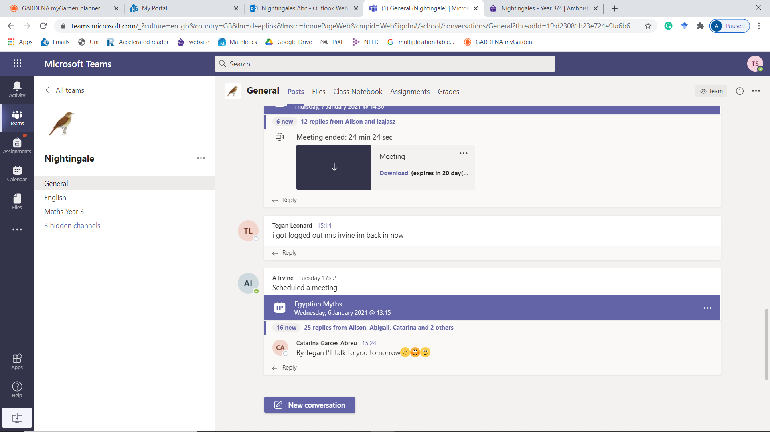

When you click on the link you will see the assignments you have been set, click on the one you want to complete

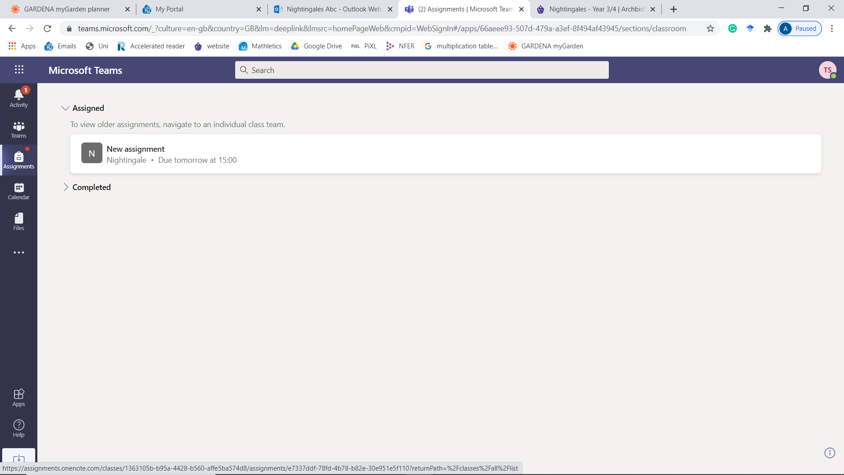

This will bring up a screen with everything you need to complete your assignment online without leaving teams

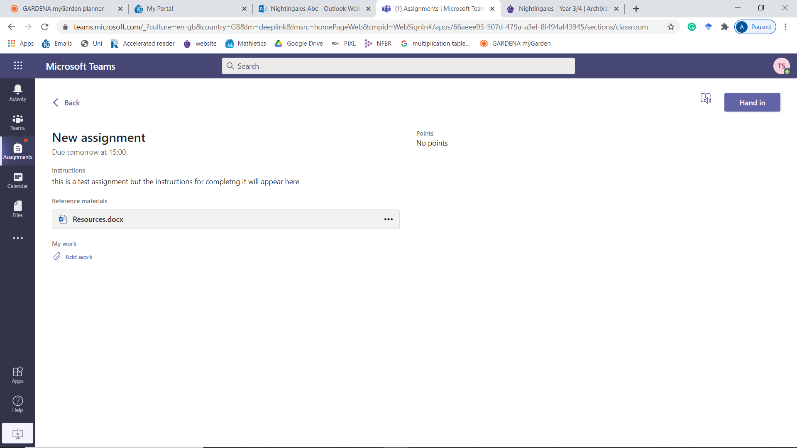

What you need to do for the assignment will appear here.

Any resources you need, e.g. word mats, plans, worksheets will appear here.

The date it should be handed in by will appear here.

To complete the work, you need to attach the work using the add work button.

Once you have clicked it you need to choose what format you will do the work in. For example, if you are doing English, you probably want to do the work in Word, if you are doing something in Geography, you may be producing a PowerPoint about your subject so click on new document and pick a format.

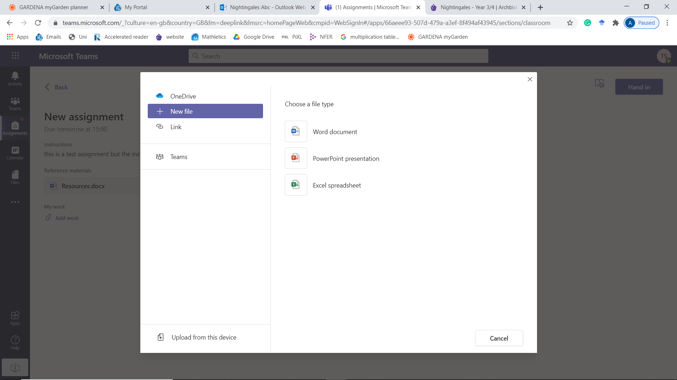

Then you need to name your document. To help the teacher, it would be helpful to name it with your initials and the assignment title, e.g. AI Geography Egypt. Do not give the documents silly names.

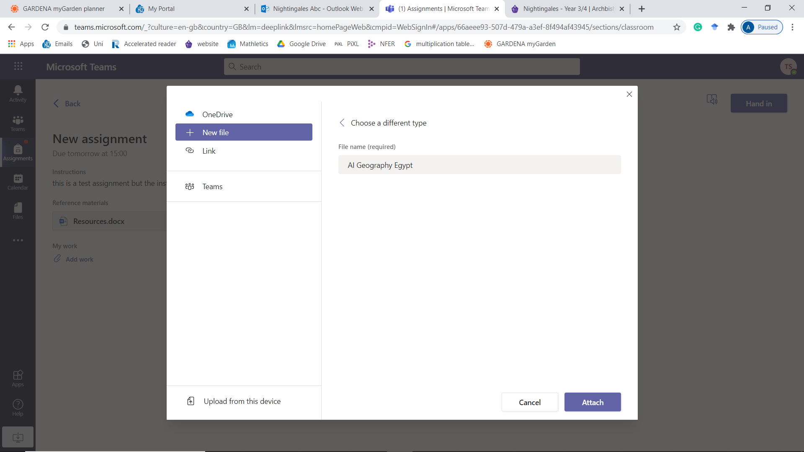

Press attach and the document is created.

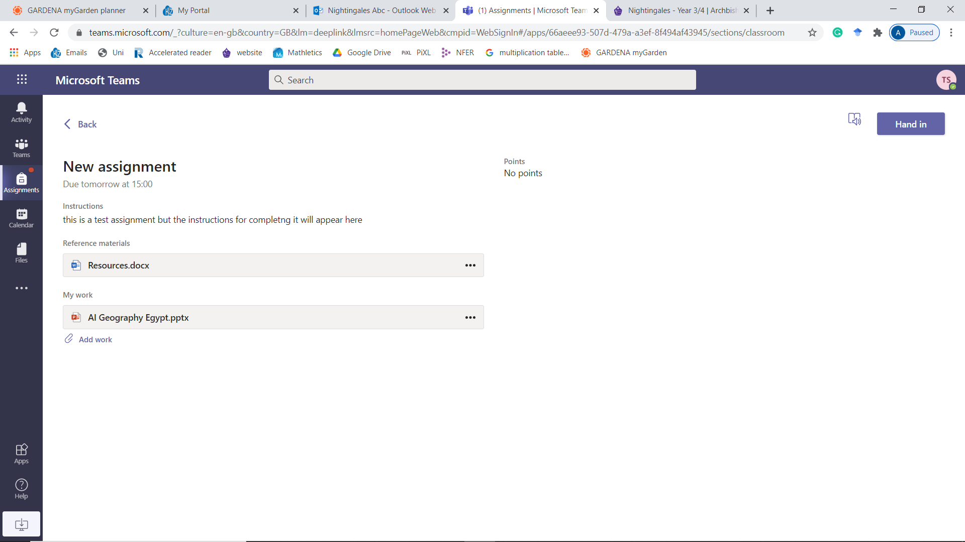

You can then click on that document to put your work in. Your Teams login allows you to access all the Microsoft Office applications so you do not have to download anything, you can type straight in to the document you have created. 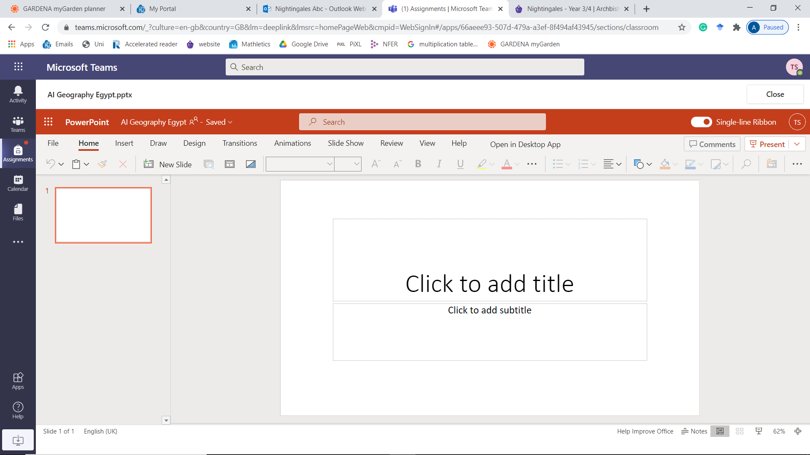

When you want to stop, just click close in the top right. You can open and close it as many times as you like until you submit it, so you don’t have to do it all in one sitting.

Once you have fully completed the project and are happy with it, you can hand in the assignment to your teacher for marking. 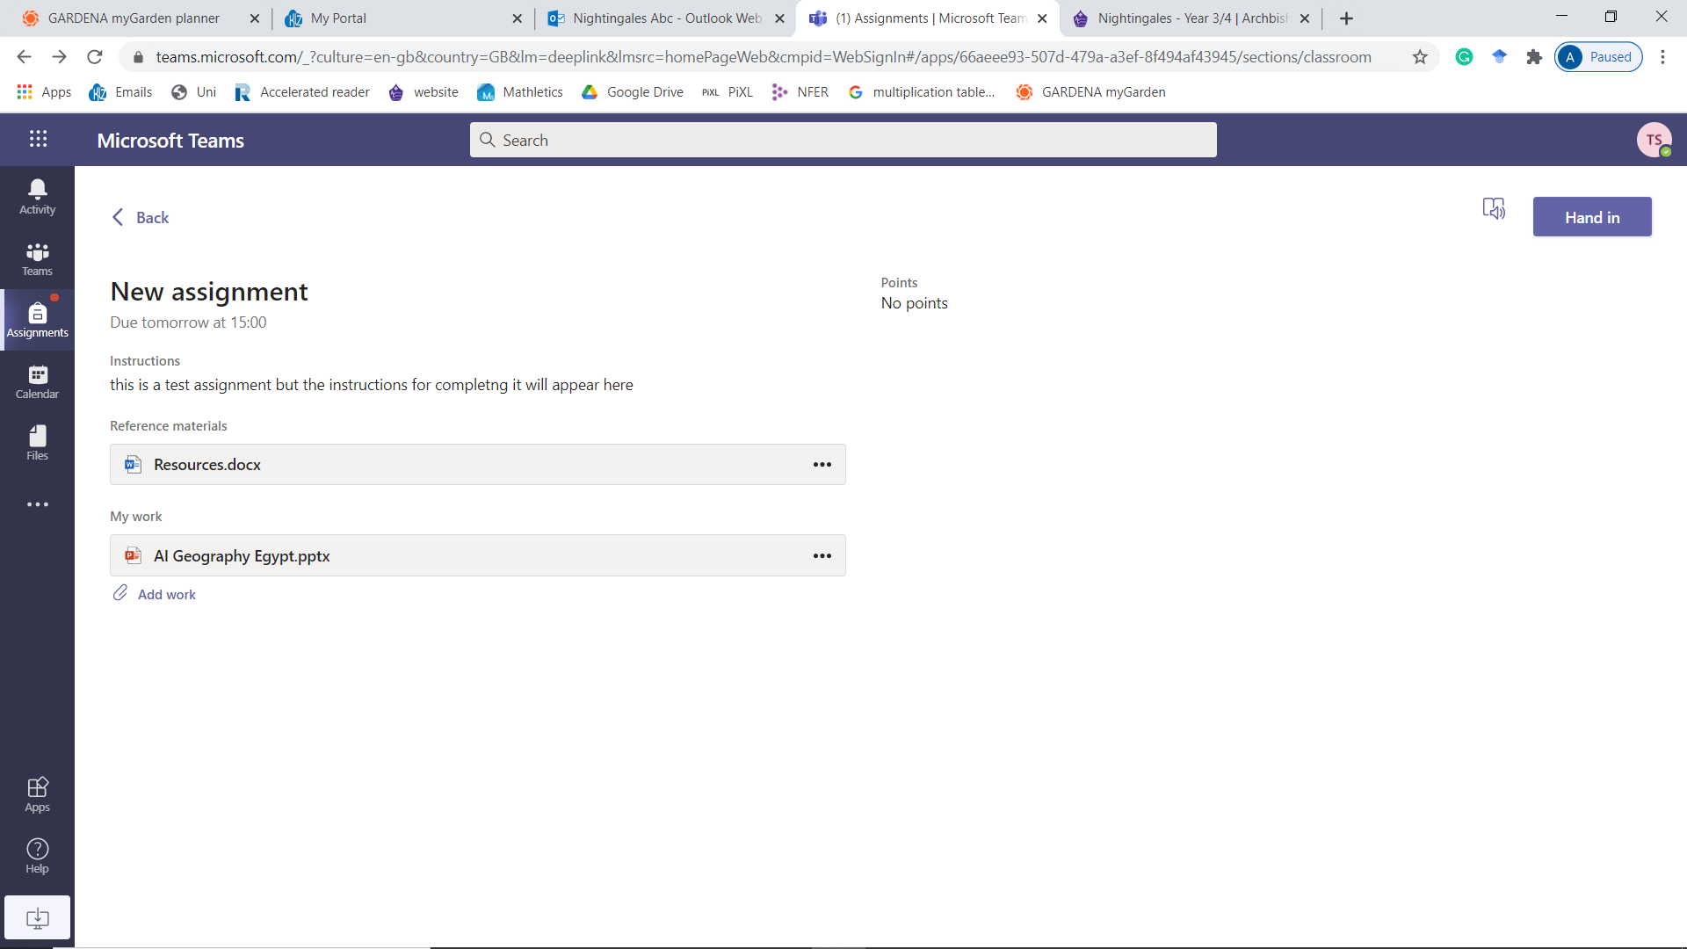

And that’s it, you have returned your assignment. Your teacher can now mark it and send it back to you with comments 😊 well done!