UKS2 Science: Term 6 – All Living Things
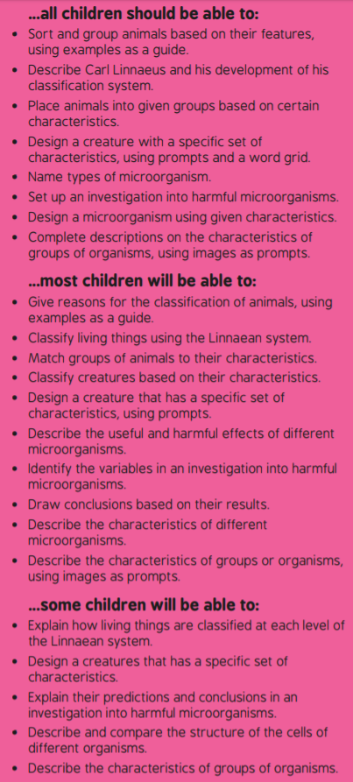 | Key questions and vocabulary – use the internet if you need to!  - Carl Linnaeus  - Linnaean  - Classification  - Standard  - Domain  - Kingdom  - Phylum  - Class  - Order  - Family  - Genus  - Species  - What does a classification system do?  - Why is it important to have a classification system?
Lesson 2
LI: To describe how living things are classified into groups.  - I can describe who Carl Linnaeus was.  - I can explain how living things are classified using the Linnaean system.  - I can classify living things using the Linnaean system. | Resources  Internet  Paper, pens and pencils  https://www.bbc.co.uk/teach/class-clips-video/science-ks2-the-work-of-carl-linnaeus/zhnjf4j  https://easyscienceforkids.com/carl-linnaeus/  https://www.bbc.co.uk/bitesize/topics/zn22pv4/articles/z3nbcwx
- A Standard System: Children discuss why it is important to have a standard system of classification. Ask children to discuss possible problems caused by not following a standard system.

- Carl Linnaeus and the Linnaean System: Describe Carl Linnaeus and his work on the classification system, using the information on the Lesson Presentation. Explain the Linnaean system of classification using the information and diagrams on the Lesson Presentation. Give examples for each level of the classification system referring to the Lesson Presentation.

- Complete the Kahoot Quiz on the Linnaean System. Game PIN: 07910343

- Classifying Species: Use the diagram on the Lesson Presentation to show the children how a species can be classified at each level of the standard system. Explain how the genus and the species gives a living thing its scientific name.

- Classifying Species Activity: Children choose one of the living things from the list on the Lesson Presentation. Children use books or the Internet to research the living thing and complete the Classifying Species Activity Sheet showing how the species is classified at each level of the standard system. Children give the scientific name of their chosen living thing using the genus and the species.

Invent a Mnemonic: Children work with their partner to invent a mnemonic to help them remember the order of the levels of the classification system.

