UKS2 Science: Term 6 – All Living Things
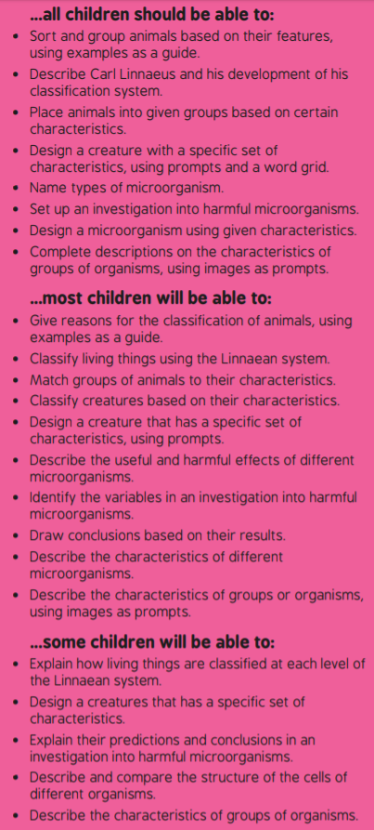 | Key questions and vocabulary – use the internet if you need to!  - Carl Linnaeus  - Linnaean  - Classification  - Standard  - Domain  - Kingdom  - Phylum  - Class  - Order  - Family  - Genus  - Species  - What does a classification system do?  - Why is it important to have a classification system?
Lesson 2
LI: To identify and classify the characteristics of different creatures  - Identify different animals  - Match types of animals to their characteristics  - Design a creature that has a set of characteristics of one type of animal  - Classify creatures based on their characteristics | Resources  Internet  Paper, pens and pencils  https://www.bbc.co.uk/bitesize/topics/zn22pv4/articles/z3nbcwx
- Recap previous learning.

- What are the differences between vertebrates and invertebrates?
We can split these creatures into smaller groups – what groups of vertebrates can we remember? What examples of animals fit into each group?

- Match the characteristics with the correct group of animals on the characteristics activity sheet.

- Describe the discovery of the platypus using the information on the presentation. What makes the platypus unique? Use the diagram to describe its characteristics – what groups of animals are these characteristics usually found in?

- Using the diagram on the presentation, explain why the platypus is classified as a mammal and not a reptile or a bird.

- Activity – design a new creature and accompanying fact file. Please make sure that children understand that their creature should exhibit characteristics of A PARTICULAR GROUP OF ANIMALS, so a partner/friend can classify it successfully later.

- Contact a friend/relative. Ask them to successfully classify your new creature.

