# **R2e. Can talk about a growing repertoire of vocabulary and know how to independently find out what unknown words in a text mean**

# **Test 1**

**Commissioned by The PiXL Club Ltd.**

**August 2018**

**This resource is strictly for the use of member schools for as long as they remain members of The PiXL Club. It may not be copied, sold nor transferred to a third party or used by the school after membership ceases. Until such time it may be freely used within the member school.**

**All opinions and contributions are those of the authors. The contents of this resource are not connected with nor endorsed by any other company, organisation or institution.**

**PiXL Club Ltd endeavour to trace and contact copyright owners. If there are any inadvertent omissions or errors in the acknowledgements or usage, this is unintended and PiXL will remedy these on written notification.**

© Copyright The PiXL Club Limited, 2018

**2e. Can talk about a growing repertoire of vocabulary and know how to independently find out what unknown words in text mean – Test 1**

*Read the text and answer the questions below. Use the spaces provided to write your answers.*

**The caves**

There were hidden spaces I had never explored in the ancient caves, which smelt musty and unused, but I had returned to what was familiar to me. Stalactites hung from the extraordinary ceilings; artefacts were strewn across the uneven floor next to rock benches where people from a past time would have sat, maybe wondering how they would escape the caves when the tide came in. I sometimes allowed myself to become consumed by thoughts about those people and their relationship with the caves, but it was the artefacts that held the fascination for me. Barrels, once round and shiny, were dull and rotting – no longer the safe haven for the precious goods they had once contained; leatherbound books lay damp and useless, the secrets they held within them silenced, and candles, long extinguished, had ripples of spilt wax dried on – evidence that they had once been alight. I wondered how I could find out what they were for, who it was that had deserted them and why they had never returned to claim them.

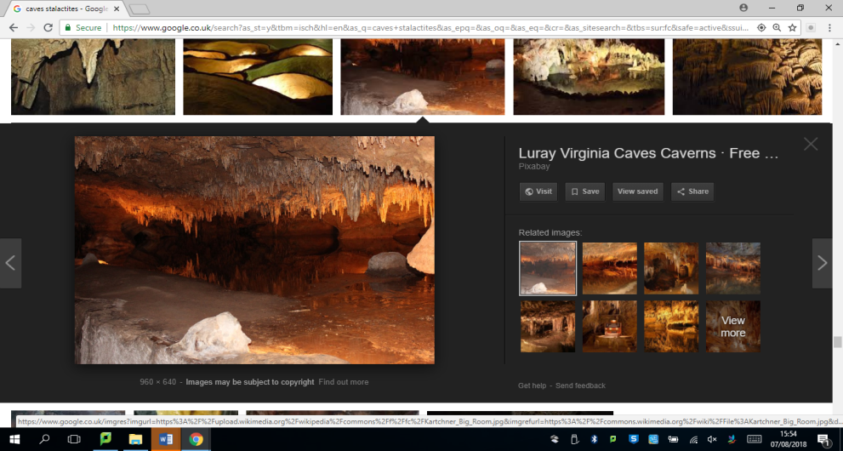

1. What is the meaning of the following words in the above text?

(You may use other resources if you do not know.)

1. stalactites _________________________________________
2. strewn ____________________________________________
3. consumed _________________________________________
4. extinguished ______________________________________

2. Write one synonym and one antonym for each word.

(You may use other resources if you do not know.)

|  |  |  |
| --- | --- | --- |
| **word** | **synonym** | **antonym** |
| ancient |  |  |
| musty |  |  |
| strewn |  |  |
| extinguished |  |  |

3. Write a new sentence for each word to show that you know how to use them in different contexts.

1. _____________________________________________________________________
2. _____________________________________________________________________
3. _____________________________________________________________________
4. _____________________________________________________________________

4. Using an age-appropriate text (ask an adult), independently complete the following table for words you do not know in the text:

|  |  |  |
| --- | --- | --- |
| **word** | **page number** | **definition** |
|  |  |  |
|  |  |  |
|  |  |  |
|  |  |  |
|  |  |  |

**2e. Can talk about a growing repertoire of vocabulary and know how to independently find out what unknown words in a text mean – Test 1**

**Answers:**

1. a) a type of formation that hangs from the ceilings of caves/a structure hanging like an icicle from the roof of a cave (formed of calcium salt and deposited water)

b) things scattered or spread untidily (over a surface or area)

c) completely fill the mind of someone/mind completely full of something (ensure children get the correct definition for this context)

d) cause a fire to cease to burn/put out

1. accept any correct anonyms/synonyms for each of the words – e.g.

* ancient – very old/recent
* musty - stuffy/fresh
* strewn – scattered/gather
* extinguished – put out/light/start up

1. accept any correct contextual use of the words in sentences – e.g.

* I delicately picked up the ancient vase.
* The old house smelt musty, like it hadn’t been lived in for years.
* His clothes were strewn across the bedroom floor, along with everything else he owned.
* He extinguished the light and made his way up the stairs.

1. accept any correct definition of words from age-appropriate text given/chosen