Can you draw different emotions on the faces?
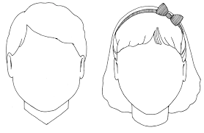
Happy Sad
Worried Excited
Upset Proud
Can you draw how you feel now?

