
Year 5-6 Problem types
Number Problems
Therapy test 1

To support the therapy for Number Problems

Commissioned by The PiXL Club Ltd.
October 2019

This resource is strictly for the use of member schools for as long as they remain members of The PiXL Club. It may not be copied, sold nor transferred to a third party or used by the school after membership ceases. Until such time it may be freely used within the member school.
All opinions and contributions are those of the authors. The contents of this resource are not connected with nor endorsed by any other company, organisation or institution.
PiXL Club Ltd endeavour to trace and contact copyright owners. If there are any inadvertent omissions or errors in the acknowledgements or usage, this is unintended and PiXL will remedy these on written notification

© Copyright The PiXL Club Limited, 2019

Therapy test 1

Y5-6 Problem types - number problems

- The number in the box above two other boxes is the sum of the two numbers below it. Work out the missing numbers.
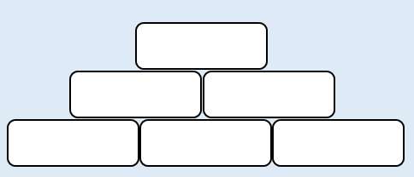
1937
3872
4352

- The number in the box above two other boxes is the product of the two numbers below it. Work out the missing numbers.
12
1.5
72

3. In this Magic Square, the sum of every row, column and diagonal is 34. Complete the missing numbers.

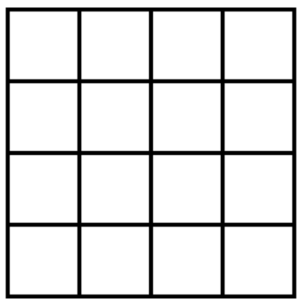
3
14
9
12
1
7
10
13

