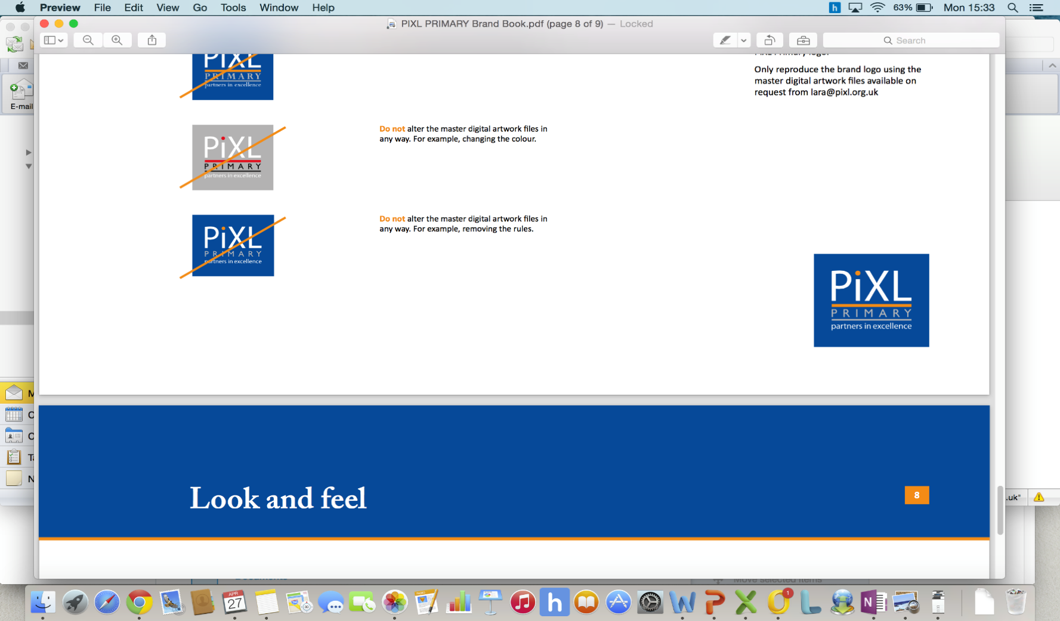

**Year 3 Skills Test 3**

# **M1c: Can find 100 more or 100 less than a given number up to 1,000.**

# **Commissioned by The PiXL Club Ltd.**

**April 2018**

This resource is strictly for the use of member schools for as long as they remain members of The PiXL Club. It may not be copied, sold nor transferred to a third party or used by the school after membership ceases. Until such time it may be freely used within the member school.

All opinions and contributions are those of the authors. The contents of this resource are not connected with nor endorsed by any other company, organisation or institution.

PiXL Club Ltd endeavour to trace and contact copyright owners. If there are any inadvertent omissions or errors in the acknowledgements or usage, this is unintended and PiXL will remedy these on written notification

© Copyright The PiXL Club Limited, 2018

**M1c: Can find 100 more or 100 less than a given number up to 1,000.**

1. **Circle** the number which shows **one hundred more than 238.** How do you know?

239 237 338 380 300

1. **Circle** the number which shows **one hundred less than 409**. How do you know?

400 399 410 309 390

1. **Circle** the number which shows **one hundred more than 680.** How do you know?

860 780 580 708 700