# **Y5 W4c Uses own planning strategies to compose and rehearse whole texts before writing**

**Skills Test 1**

**Commissioned by The PiXL Club Ltd.**

**October 2019**

**This resource is strictly for the use of member schools for as long as they remain members of The PiXL Club. It may not be copied, sold nor transferred to a third party or used by the school after membership ceases. Until such time it may be freely used within the member school.**

**All opinions and contributions are those of the authors. The contents of this resource are not connected with nor endorsed by any other company, organisation or institution.**

**PiXL Club Ltd endeavour to trace and contact copyright owners. If there are any inadvertent omissions or errors in the acknowledgements or usage, this is unintended and PiXL will remedy these on written notification.**

© Copyright The PiXL Club Limited, 2019

**Y5 W4c Uses own planning strategies to compose and rehearse whole texts before writing – Test 1**

1. Give three reasons why it is important to plan a whole text before writing.

a. _____________________________________

b. _____________________________________

c. _____________________________________

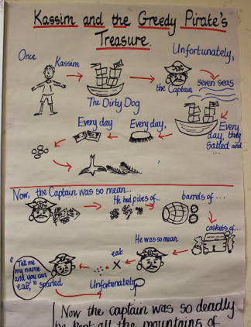2. Imagine your teacher has asked you to write a non-chronological report about one of your hobbies. Produce a plan for this piece of writing using the planning frame that you think is most suitable – there are some ideas below.

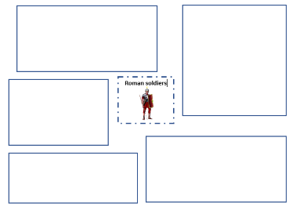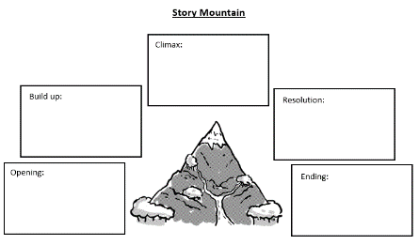

3. Using either your plan from above or a plan that you have recently written in class, rehearse your whole text with a partner. Remember to think about how you will link your ideas from one section to the next.

**Y5 W4c Uses own planning strategies to compose and rehearse whole texts before writing – Test 1**

**Answers:**

1. Give three reasons why it is important to plan a whole text before writing.

a. to organise the ideas so that you reach a conclusion

b. so that our writing flows cohesively for the reader

c. to help to rehearse our whole text before we write

2. Imagine your teacher has asked you to write a non-chronological report about one of your hobbies. Produce a plan for this piece of writing using the planning frame that you think is most suitable – there are some ideas below.

*****Accept any planning frame which pupils are comfortable with and allows them to successfully carry out the task. This frame works well for reports where information needs to be gathered before the best order is decided upon.*

3. Using either your plan from above or a plan that you have recently written in class, rehearse your whole text with a partner. Remember to think about how you will link your ideas from one section to the next.

*Ensure that, as pupils rehearse, they include all the information in their plan, linking one section to the next until they have reached a conclusion.*