Group names: ________________________________________________________________________________

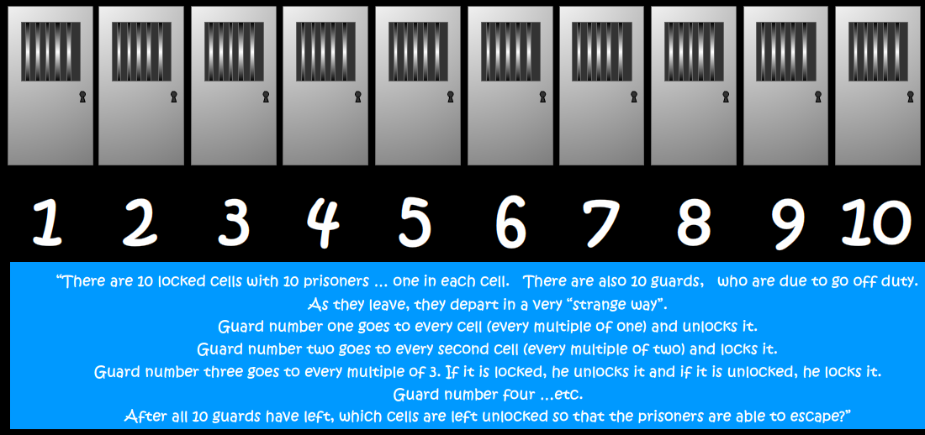

1. For 10 prisoners, which doors will be open?
2. For 20 prisoners, which doors will be open?
3. For 100 prisoners, which doors will be open?
4. Is there a pattern or rule controlling which doors are open? Describe it using words and ideas you have learned in maths.
5. If there were 1,000 doors, would prisoner #400 escape? Explain why.

Bonus question: Why does this pattern occur?