Religious Education Home Learning

EYFS – Why do Christians put a cross in an Easter Garden?
Give the children simple images from the Easter story to take home to reorder and retell the story. Can they either match the images with key words or write simple sentences underneath describing what is happening.
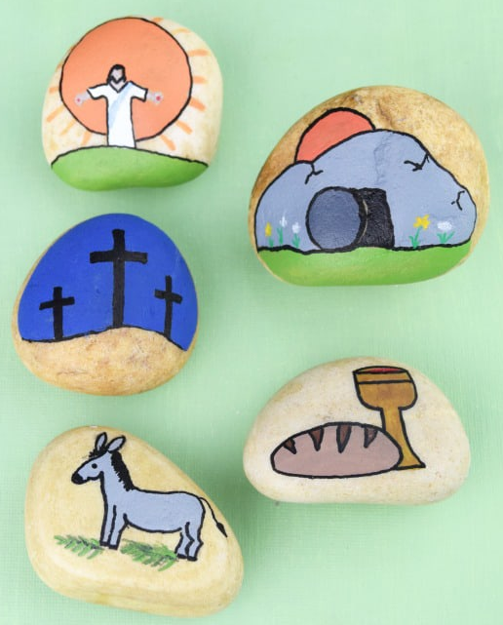
https://www.bbc.co.uk/cbeebies/stories/lets-celebrate-easterperformance
https://www.bbc.co.uk/cbeebies/watch/lets-celebrate-easter

KS1 – Why does Easter matter to Christians?
https://www.youtube.com/watch?v=bkNTU_Vv5Ew – Beginners Bible Easter Story
https://www.youtube.com/watch?v=Wnbo2AmS3OI Religions of the world – Easter story

Can they use these images to retell the Easter story? Can they use them to come up with an answer – why does Easter matter to Christians?

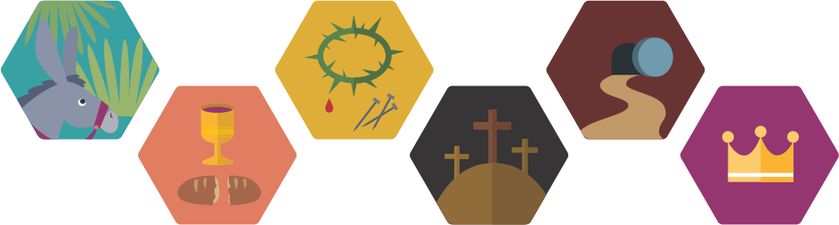

Easter poems
Share this Easter acrostic poem with pupils.

Easter is a time when Christians think about Jesus.
A time when Jesus died on the cross.
Sad parts of the story are remembered at Easter.
There are such happy parts too!
Especially when Jesus rose from the dead.
Rejoicing happens at Easter.

Discuss features of the poem, including each line starting with a given letter from the word, lines all relating to the topic, and the fact that no rhyming is necessary.
Encourage them to have a go at writing their own poem about Easter.
LKS2 – Why do Christians call the day Jesus died good?
https://www.youtube.com/watch?v=MK2o-mhBfuc&list=PLcvEcrsF_9zLNjB-h9xjVlhgG8f0fjk-9&index=3 My life, my religion – Easter
https://request.org.uk/restart/2017/06/05/bible-quest-holy-week/ The Easter story.

You have been asked to create a display for your local church either to go in a window that can be seen from outside the church, or another form of presentation that can go on the church website, showing the importance of either Palm Sunday, Good Friday or Easter Sunday. (It could be a power point, poster or piece of artwork)

Can you include a suitable cross with an explanation about what this reminds Christians of.
A recount of the key part of the Eater story linked to your display.

You might title each of the displays:
Why is Palm Sunday so important to Christians?
Why do Christians call the day Jesus died Good Friday?
What do Christians believe happened on Easter Sunday?
(Taken from Core learning – making connections)

Year 5 – What did Jesus do to save human beings? & Year 6 – What difference does the resurrection make to Christians?

The command to ‘Love your neighbour as you love yourself’ will involve some sacrifice.
What does it mean to sacrifice something? (the act of giving up something that you want to keep especially in order to get or do something else or to help someone.)
Ask pupils to draft a short charter for the school, local community or the world (if they can get that far) to explain how far the idea of sacrifice is good and necessary for making
the world a better place. They should make links with Christian ideas and Jesus’ teachings. It is perfectly fine for them to say that sacrifice is not good, but they must offer good reasons and alternatives that will make the world a better place!
(Taken from Year 5 Core learning – making connections)

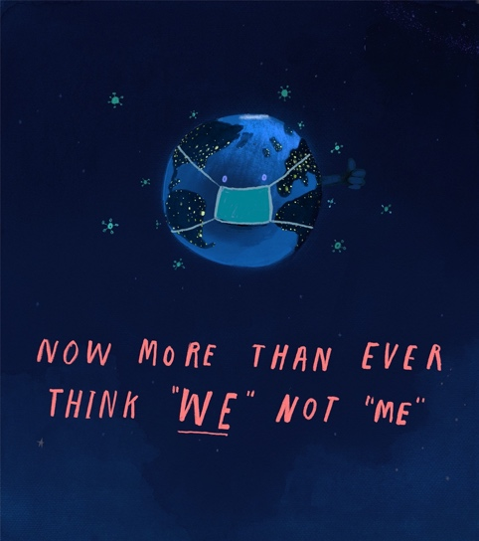
What sacrifices might people be making at the moment? How could you sacrifice something to help someone else?

EYFS
This term in Religious Education we have been learning about the religion Christianity and trying to answer our unit big question: Why do Christians put a cross in an Easter Garden?

- I wonder what you can remember about the Easter story? Can you talk about these picture with someone at home? Use these words to help you.

Jesus | cross | donkey
Palm Sunday | Easter Sunday | tomb
Good Friday | died | alive
happy | sad | forgiven

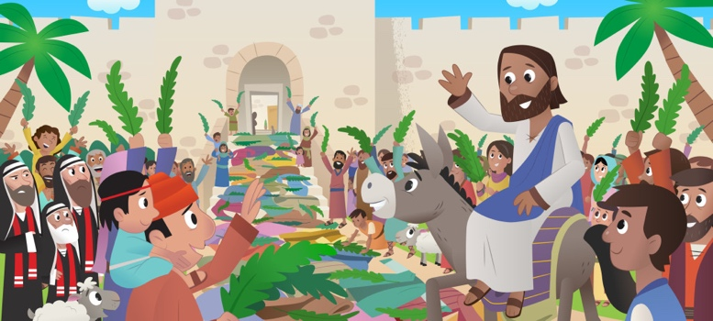

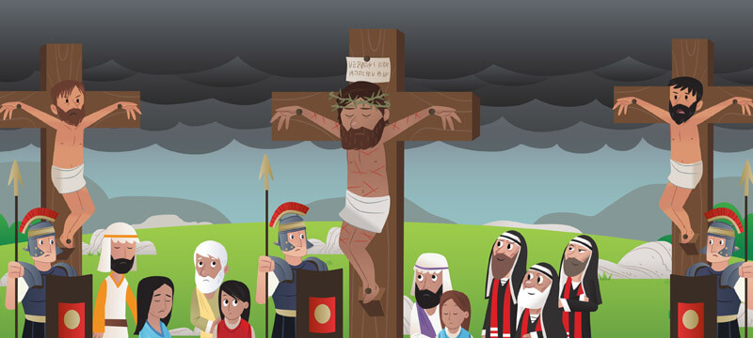

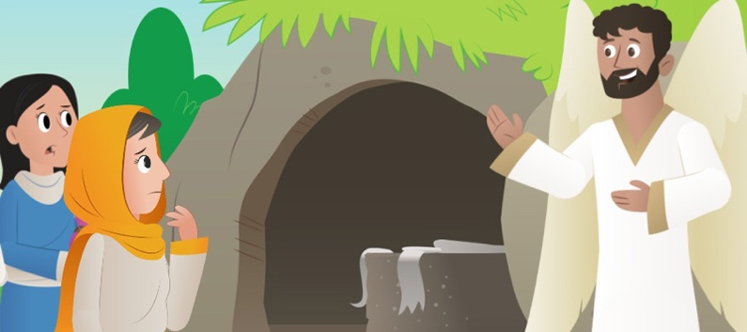

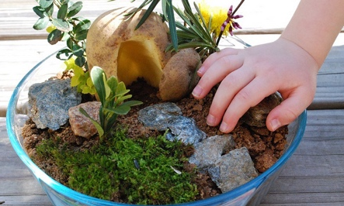

- I wonder if you can make an Easter garden like Tom and Tessa did using things you can find at home or in your garden?
- Can you remember why they put a cross in their garden? Why is it important?

Here are some videos that might remind you of the story and why Christians celebrate Easter each year.
https://www.bbc.co.uk/cbeebies/stories/lets-celebrate-easterperformance
https://www.bbc.co.uk/cbeebies/watch/lets-celebrate-easter
KS1
This term in Religious Education we have been learning about the religion Christianity and trying to answer our unit big question: Why does Easter matter to Christians?

- I wonder if you can use this images to help you remember and retell the Easter story? What does each picture represent?
- I wonder which part of the story you think is the most important?
- I wonder why there is a crown in the last picture?

Easter poem

Easter is a time when Christians think about Jesus.
A time when Jesus died on the cross.
Sad parts of the story are remembered at Easter.
There are such happy parts too!
Especially when Jesus rose from the dead.
Rejoicing happens at Easter.

I wonder if you can make your own Easter acrostic poem? Can you include things you have learned about the Easter story?

These video clips might help remind you of the story and why Christians celebrate Easter each year.
https://www.youtube.com/watch?v=bkNTU_Vv5Ew – Beginners Bible Easter Story
https://www.youtube.com/watch?v=Wnbo2AmS3OI Religions of the world – Easter story

I wonder if these words might help your writing?

Jesus | cross | donkey
Palm Sunday | Easter Sunday | tomb
Good Friday | died | alive
happy | sadness | forgiven
joy | God | rose
An Easter poem

E

A

S

T

E

R

LKS2
This term in Religious Education we have been learning about the religion Christianity trying to answer our unit big question: Why do Christians call the day Jesus died good?

Task:
You have been asked to create a display for your local church either to go in a window that can be seen from outside the church, or another form of presentation that can go on the church website. (This could be in the form of a power point, poster or piece of artwork)
It needs to show the importance of either, Palm Sunday, Good Friday or Easter Sunday to Christians.

It needs to include a suitable cross with an explanation about what this reminds Christians of, and a creative recount of the key part of the Easter story linked to your display, that is suitable for younger and older people.

These video clips might help remind you of the story and why Christians celebrate Easter each year.
https://www.youtube.com/watch?v=MK2o-mhBfuc&list=PLcvEcrsF_9zLNjB-h9xjVlhgG8f0fjk-9&index=3 My life, my religion – Easter
https://request.org.uk/restart/2017/06/05/bible-quest-holy-week/ The Easter story.

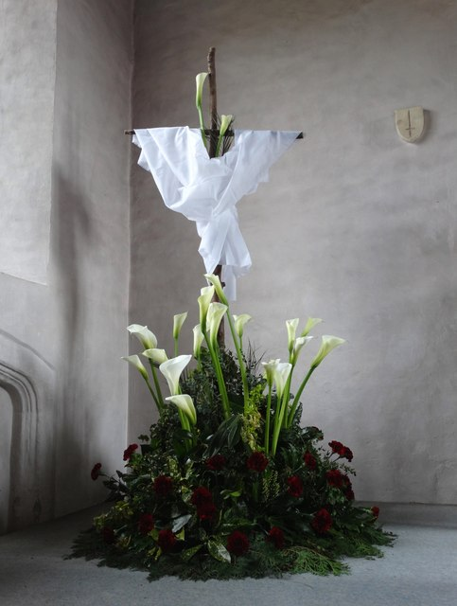

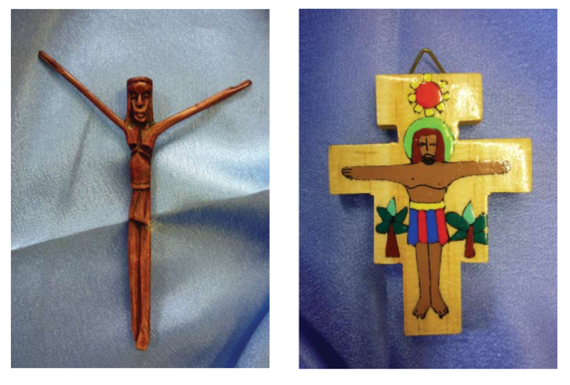
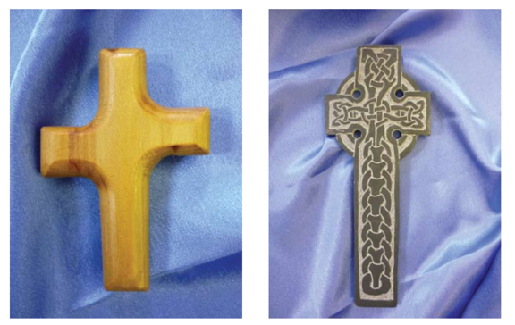

UKS2
This term in Religious Education we have been learning about the religion Christianity trying to answer our unit big question: Year 5 – What did Jesus do to save human beings?
Year 6 – What difference does the resurrection make to Christians?

The command to ‘Love your neighbour as you love yourself’ will involve some sacrifice.
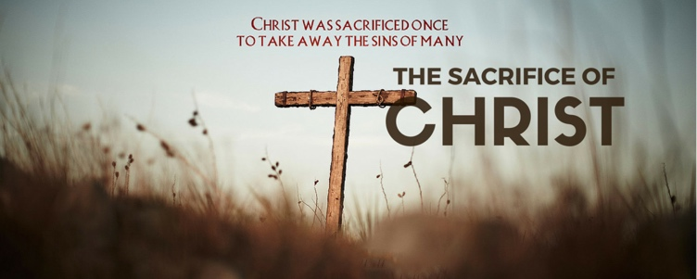
Do you agree? Why/ why not?
The Bible tells Christians that Jesus sacrificed
himself for the sins of the world, so they
could be forgiven.
What impact do you think this sacrifice have
on the lives of Christians?

- What does it mean to sacrifice something?
Dictionary definition: the act of giving up something that you want to keep especially in order to get or do something else or to help someone.

Does the dictionary definition match your thinking?
- Do you think everyone is able to sacrifice something for someone else?

- What difference would it make to the world if everyone loved their neighbour and made sacrifices for others?
Task: Create a poster for your school, local community or the world (you can choose) to help them understand that to make sacrifices for others is a good and necessary thing for making the world a better place.
- What sacrifices might people be making at the moment? How could you sacrifice something to help someone else?

