Read Orbisa’s story – she lives in Ethiopia with her 2 children.
As you read this story, think about how freedom and justice would help this family.

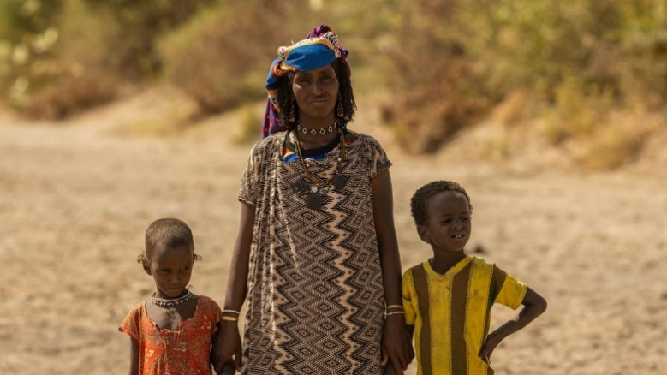

‘Life is very challenging here; we have no food and are dependent on our livestock for our livelihood. Whenever there is no rainfall, our animals die as there is no grass or water. This affects our lives significantly. We will not get money or have milk to drink. We have no other option,’ says Orbisa.
During the rainy season, Orbisa could collect water from a river just five minutes’ walk from her village. As the dry season has extended due to the changing climate, this river has now dried up and no longer provides for Orbisa and her family. ‘The water I collect is not sufficient, I am only able to collect less than half of what my family needs each day’, she says. Now, Orbisa has to walk for up to ten hours every day to collect water for her family. Due to the searing heat, Orbisa is forced to start walking before sunrise, often leaving her village at 4am. The walk is very dangerous as she faces wild animals, including hyenas and leopards.
‘The water I collect is not sufficient, I am only able to collect less than half of what my family needs each day. We need most of it for drinking, but sometimes it is not enough, and my family has to go to bed thirsty. I feel extremely sad whenever I cannot provide water for my children,’ says Orbisa.
- How would you feel if you were Orbisa and why?

Tearfund

Toilet twinning

- How is Tearfund living out Jesus’ two commandments for Orbisa?

- How is Tearfund bringing freedom and justice to Orbisa?


Thinking about all you have read, thought about and learned in this lesson, answer this question:
- How do Christians apply the ideas of freedom and justice to their ways of living in the world today?

