**Reading extract and questions:**

**Year 2**

**Passover**

**Set A/B**

**A celebration**

Passover, or Pesach as it is also known, is one of the most important holidays for Jewish people. In this country, it lasts for a period of eight days, which begins and ends with two days of rest. It is celebrated with special meals, prayers and activities. Most of these activities are done for a particular reason going back to the first Passover. The Seder meal is a key part of the celebration. This is when family and friends gather together to eat food which has a special meaning in the story of Passover. This is when the Jewish people remember how they escaped from their lives as slaves in Egypt over three thousand years ago.

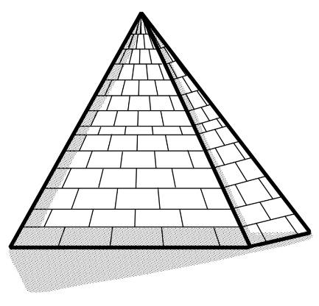**A tragic story**

The Passover story tells of how the Jews were forced to work for the people of Egypt. They wanted to leave but the Egyptian king, the Pharaoh, would not let their useful workers go. The God of the Jews was not happy. He sent ten terrible plagues to force Pharaoh to change his mind. These horrible events included turning the river Nile into blood, sending swarms of flies, killing animals with diseases and turning the sky dark for three days. Still, Pharaoh would not let the Jews go free. In the end, God sent an angel to kill the oldest boy in every house. To protect their own children, the Jews were told to brush the blood of a lamb on the frames of their doors. This would let the angel know that a Jewish family lived within so that it could miss out or ‘pass over’ that house.

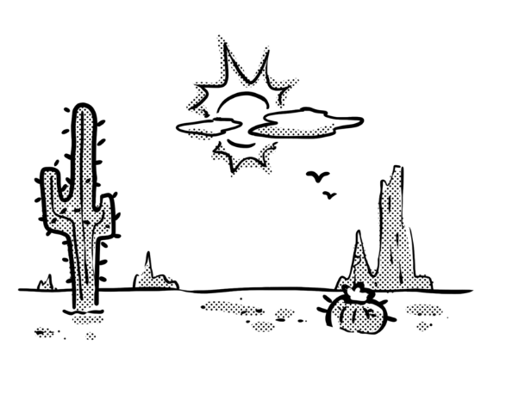**Escape!**

This was too much for the Egyptians. They told Pharaoh to send the Jews away. As quickly as they could, the Jewish people picked up some things they would need for their journey across the desert and escaped to freedom. They did not even wait to add yeast to their bread dough to make it rise. That is why unleavened bread – bread that has not been given anything to make it rise – plays such an important part in modern Passover festivities.

**Questions for**

**Passover**

**Set A**

**Vocabulary**

**1.** *It is celebrated with special meals* … In this sentence, *celebrated* means … **Tick one**.

**danced rewarded**

**marked won**

**2**. Look at the sentence beginning *The Passover story tells …* **Find** and **copy** a word that means *made*.

_________________________________________________________________

**3.** *… He sent ten terrible plagues* … In this sentence, *plagues* means … **Tick one**.

**diseases horrible events**

**annoying things small problems**

**Identify key aspects**

**4.** When did the Jewish people escape from their lives as slaves in Egypt?

_________________________________________________________________

**5.** Give two of the terrible plagues named in the text.

1. ___________________________________ **b.** ___________________________________

**Inference**

**6.** Why did Pharaoh not want to let the Jews go?

_________________________________________________________________

**Sequence**

**7.** Number the sections from **1** to **4** to show the order in which they appear.

|  |  |
| --- | --- |
| Escape! |  |
| Title |  |
| A tragic story |  |
| A celebration |  |

**Predict**

**8.** What do you think would have happened if the Jews had not escaped straight away?

_______________________________________________________________________________

**Questions for**

**Passover**

**Set B**

**Vocabulary**

**1.** Look at the sentence beginning *These horrible events …* **Find** and **copy** a word that means *huge amounts*.

_________________________________________________________________

**2.** *… journey across the desert* … In this sentence, *journey* means … **Tick one**.

**trip plan**

**day meal**

**Identify key aspects**

**3.** Name **two** ways in which Passover is celebrated.

**a.**________________________________  **b.** _____________________________

**4.** What was the Egyptian king also known as?

_________________________________________________________________

**5.** How did one of the plagues kill the Egyptians’ animals?

_________________________________________________________________

**Inference**

**6.** Why did the Jewish people pick up their things *as quickly as they could*?

_________________________________________________________________

**Sequence**

**7.** Number the parts of the Passover story from **1** to **4** to show the order in which they happened.

|  |  |
| --- | --- |
| The Jewish people were slaves in Egypt. |  |
| God sent ten terrible plagues. |  |
| The Egyptian king would not let them go. |  |
| The Jewish people escaped. |  |

**Predict**

**8.** What would the Jewish people say to the Egyptian king if he tried to keep them as slaves again?

_______________________________________________________________________________



**Answers for *Passover***

**Set A:**

**Vocabulary:**

**1.** marked

**2.** forced

**3.** horrible events

**Retrieval:**

**4.** (over) three thousand years ago

**5.** Accept any two from:turning the Nile into blood; swarms of flies; killing animals with diseases; turning the sky dark for three days; sending an angel to kill the oldest boy.

**Inference:**

**6.** because they were useful workers

**Sequence:**

|  |  |
| --- | --- |
| Escape! | **4** |
| Title | **1** |
| A tragic story | **3** |
| A celebration | **2** |

**7.**

**Predict:**

**8.** Pharaoh might have changed his mind about letting them go/made them stay.

**Commissioned by The PiXL Club Ltd.** **July 2019**

This resource is strictly for the use of member schools for as long as they remain members of The PiXL Club. It may not be copied, sold nor transferred to a third party or used by the school after membership ceases. Until such time it may be freely used within the member school.

All opinions and contributions are those of the authors. The contents of this resource are not connected with nor endorsed by any other company, organisation or institution.

PiXL Club Ltd endeavour to trace and contact copyright owners. If there are any inadvertent omissions or errors in the acknowledgements or usage, this is unintended and PiXL will remedy these on written notification.

© Copyright The PiXL Club Limited, 2019



**Answers for *Passover***

**Set B:**

**Vocabulary:**

**1.** swarms

**2.** trip

**Retrieval:**

**3.** Accept any two from: special meals (with family and friends), prayers, activities, resting.

**4.** Pharaoh

**5.** disease

**Inference:**

**6.** So that they could get away as soon as possible/before the Egyptians/Pharaoh changed their minds.

**Sequence:**

**7.**

|  |  |
| --- | --- |
| The Jewish people were slaves in Egypt. | **1** |
| God sent ten terrible plagues. | **3** |
| The Egyptian king would not let them go. | **2** |
| The Jewish people escaped. | **4** |

**Predict:**

**8.** Accept answers that refer back to the Passover story, e.g.“You had better let us go or God will be angry.” Or “Let us go because you know what happened last time.”

**Commissioned by The PiXL Club Ltd.** **July 2019**

This resource is strictly for the use of member schools for as long as they remain members of The PiXL Club. It may not be copied, sold nor transferred to a third party or used by the school after membership ceases. Until such time it may be freely used within the member school.

All opinions and contributions are those of the authors. The contents of this resource are not connected with nor endorsed by any other company, organisation or institution.

PiXL Club Ltd endeavour to trace and contact copyright owners. If there are any inadvertent omissions or errors in the acknowledgements or usage, this is unintended and PiXL will remedy these on written notification.

© Copyright The PiXL Club Limited, 2019