**BRONZE**

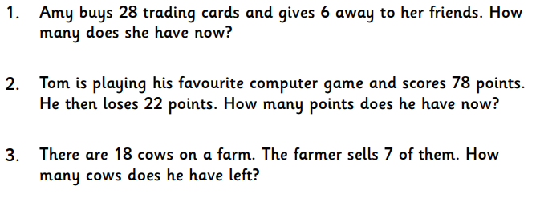

**SILVER**

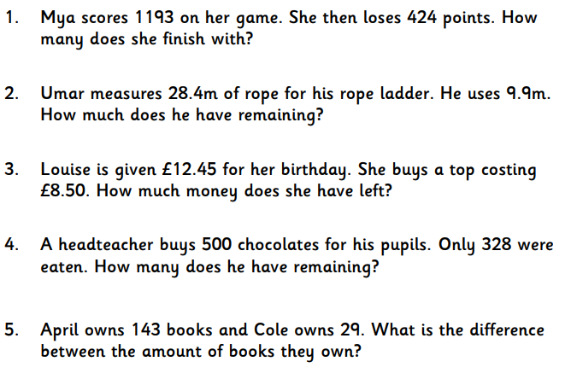

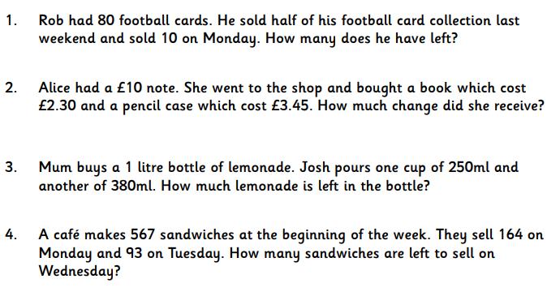**GOLD**

**PLATNIUM**

**Come up with your own words problems for the class to try and complete tomorrow! Work the answer out yourself so you can tell people if they are right or wrong.**