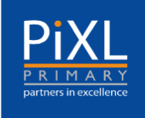
Year 4 Skills Test 1

M2a: Can add 2-digit and extend to 3-digit numbers using the formal method.

Commissioned by The PiXL Club Ltd.
April 2018

This resource is strictly for the use of member schools for as long as they remain members of The PiXL Club. It may not be copied, sold nor transferred to a third party or used by the school after membership ceases. Until such time it may be freely used within the member school.
All opinions and contributions are those of the authors. The contents of this resource are not connected with nor endorsed by any other company, organisation or institution.
PiXL Club Ltd endeavour to trace and contact copyright owners. If there are any inadvertent omissions or errors in the acknowledgements or usage, this is unintended and PiXL will remedy these on written notification

© Copyright The PiXL Club Limited, 2018

M2a: Can add 2-digit and extend to 3-digit numbers using the formal method.

- 312 + 45 + 17 =

- Find the sum of £124, £109 and £85.

3. What is the total of 721 and 463?

