
Year 4 Therapy Test 1

To support M5e – Can read, write and convert between analogue and digital 12 and 24-hour clocks

Commissioned by The PiXL Club Ltd.
November 2019

This resource is strictly for the use of member schools for as long as they remain members of The PiXL Club. It may not be copied, sold nor transferred to a third party or used by the school after membership ceases. Until such time it may be freely used within the member school.
All opinions and contributions are those of the authors. The contents of this resource are not connected with nor endorsed by any other company, organisation or institution.
PiXL Club Ltd endeavour to trace and contact copyright owners. If there are any inadvertent omissions or errors in the acknowledgements or usage, this is unintended and PiXL will remedy these on written notification.

© Copyright The PiXL Club Limited, 2019

Therapy Test 1

Y4 M5e Can read, write and convert between analogue and digital 12 and 24 - hour clocks

- This analogue clock shows the time in the morning. Write this as a digital time.

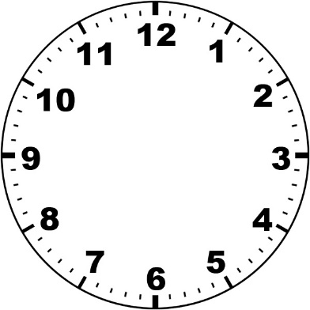

- This analogue clock shows the time in the evening. What is the time shown? Write this as a 24-hour digital time.

- The time is 17:23 on a digital clock. Show this time on an analogue clock and state whether it is am or pm.

