
Year 4 Therapy Test 1

To support M5f – Can estimate length

Commissioned by The PiXL Club Ltd.
November 2019

This resource is strictly for the use of member schools for as long as they remain members of The PiXL Club. It may not be copied, sold nor transferred to a third party or used by the school after membership ceases. Until such time it may be freely used within the member school.
All opinions and contributions are those of the authors. The contents of this resource are not connected with nor endorsed by any other company, organisation or institution.
PiXL Club Ltd endeavour to trace and contact copyright owners. If there are any inadvertent omissions or errors in the acknowledgements or usage, this is unintended and PiXL will remedy these on written notification.

© Copyright The PiXL Club Limited, 2019

Therapy Test 1

Y4 M5f. Can estimate length

- Estimate the length of the table:
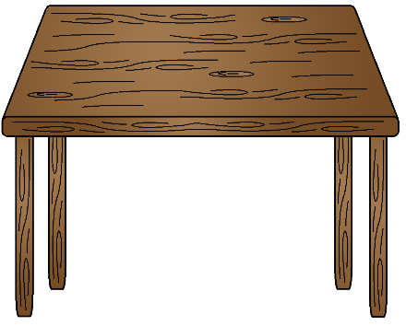
Answer:

3m
0m

- The orange KS1 chairs are 80cm tall. Estimate the height of the red KS2 chairs.
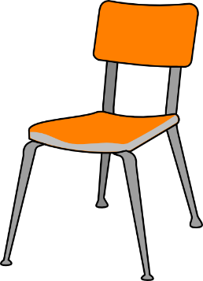
Answer:


- Oliver estimates that the yellow blocks are 15cm tall and the blue blocks are 50cm tall. Could he be correct? Explain your reasoning.

______________________________________________
______________________________________________

______________________________________________

______________________________________________

