
Year 4 Therapy Test 1

To support M5g – Can estimate mass

Commissioned by The PiXL Club Ltd.
November 2019

This resource is strictly for the use of member schools for as long as they remain members of The PiXL Club. It may not be copied, sold nor transferred to a third party or used by the school after membership ceases. Until such time it may be freely used within the member school.
All opinions and contributions are those of the authors. The contents of this resource are not connected with nor endorsed by any other company, organisation or institution.
PiXL Club Ltd endeavour to trace and contact copyright owners. If there are any inadvertent omissions or errors in the acknowledgements or usage, this is unintended and PiXL will remedy these on written notification.

© Copyright The PiXL Club Limited, 2019

Therapy Test 1

Y4 M5g. Can estimate mass

- One medium-sized ball weighs 45g. Estimate the mass of the bag of balls:

Answer:

- The mass of one carrot is 40g. What is the estimated mass of the parsnip?
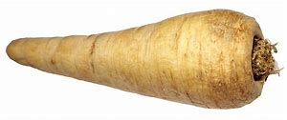
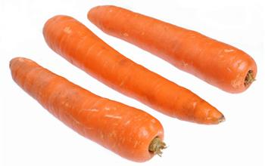
Answer:

- Jasmine reads the scales and knows that the bowl of nuts weighs 65g. Estimate the mass of one nut. Explain your reasoning.









