
Year 4 Therapy Test 1

To support M5h – Can estimate capacity

Commissioned by The PiXL Club Ltd.
November 2019

This resource is strictly for the use of member schools for as long as they remain members of The PiXL Club. It may not be copied, sold nor transferred to a third party or used by the school after membership ceases. Until such time it may be freely used within the member school.
All opinions and contributions are those of the authors. The contents of this resource are not connected with nor endorsed by any other company, organisation or institution.
PiXL Club Ltd endeavour to trace and contact copyright owners. If there are any inadvertent omissions or errors in the acknowledgements or usage, this is unintended and PiXL will remedy these on written notification.

© Copyright The PiXL Club Limited, 2019

Therapy Test 1

Y4 M5h. Can estimate capacity

- When full, the glass has a capacity of 300ml. Estimate the amount of liquid in the glass.
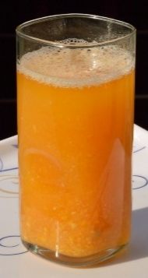
Answer:



- There is 450ml of liquid in this container. Estimate the capacity of the container when full.
Answer:

- Jenny knows the capacity of her glass is 600ml. She estimates that there is 300ml of liquid in the glass. Is she correct? Explain your reasoning.









