**  
Year 4 Therapy Test 1**

# To support M6e – Can identify lines of symmetry in 2-D shapes presented in different orientations

# **Commissioned by The PiXL Club Ltd.**

**January 2020**

This resource is strictly for the use of member schools for as long as they remain members of The PiXL Club. It may not be copied, sold nor transferred to a third party or used by the school after membership ceases. Until such time it may be freely used within the member school.

All opinions and contributions are those of the authors. The contents of this resource are not connected with nor endorsed by any other company, organisation or institution.

PiXL Club Ltd endeavour to trace and contact copyright owners. If there are any inadvertent omissions or errors in the acknowledgements or usage, this is unintended and PiXL will remedy these on written notification.

© Copyright The PiXL Club Limited, 2019

**Therapy Test 1**

**Y4 M6e. Can identify lines of symmetry in 2-D shapes presented in different orientations**

1. **Tick** the shapes that have more than one line of symmetry:

1. Olivia says that a scalene triangle does not have any lines of symmetry. Is she correct? Explain how you know.

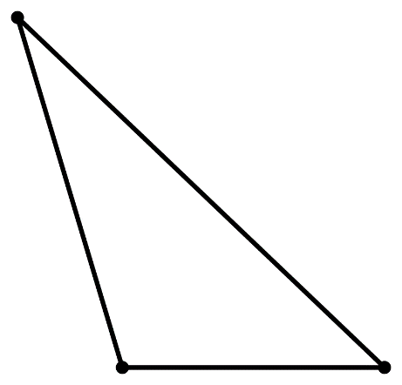

__________________________________________  
__________________________________________   
__________________________________________  
__________________________________________  
__________________________________________

3. Draw a shape to match the following statements:

Only a horizontal line of symmetry

Only a vertical line of symmetry