**  
Year 4 Therapy Test 1**

# To support M6f – Can complete a simple shape or diagram with respect to a specific line of symmetry

# **Commissioned by The PiXL Club Ltd.**

**January 2020**

This resource is strictly for the use of member schools for as long as they remain members of The PiXL Club. It may not be copied, sold nor transferred to a third party or used by the school after membership ceases. Until such time it may be freely used within the member school.

All opinions and contributions are those of the authors. The contents of this resource are not connected with nor endorsed by any other company, organisation or institution.

PiXL Club Ltd endeavour to trace and contact copyright owners. If there are any inadvertent omissions or errors in the acknowledgements or usage, this is unintended and PiXL will remedy these on written notification.

© Copyright The PiXL Club Limited, 2019

**Therapy Test 1**

**Y4 M6f. Can complete a simple shape or diagram with respect to a specific line of symmetry**

1. Complete the following shape using the line of symmetry:



2. Luke says that an equilateral triangle is the only triangle that can have a vertical line of symmetry. Is he correct? Complete the image and explain how you know.



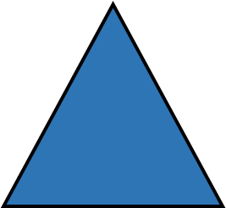

1. PRACTICAL TASK: Draw a **symmetrical image or pattern** for a partner. Fold your image in half along the **symmetrical line** and see if your partner can replicate the rest of the image. Examples include butterflies, flowers and rockets.