Design a boat
Objective: To design a boat that will take the maximum number of passengers
The big questions:  - How do boats float?  - What materials are best for boat-making?  - Does the shape of a boat impact the number of passengers it can take?  - What is the best shape for a boat for taking the most passengers?  - Have you produced ‘valid data?’  - How might you improve this experiment? | Things to think about  What does valid data mean?
 | 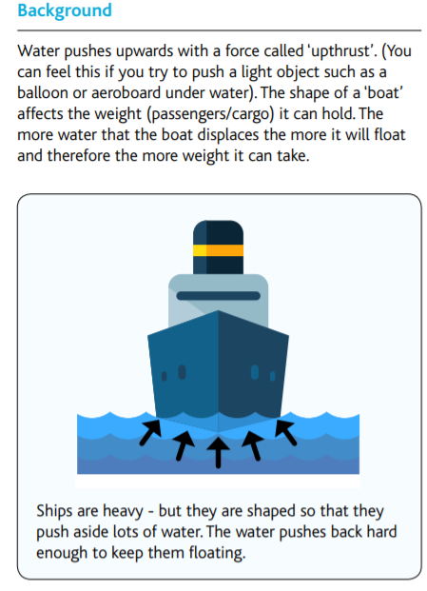
Materials
- Junk modelling materials and glue/tape
- Passengers (I suggest using similar sized stones or even peas – but any objects of a similar size and shape will work)
- A container of water
- Create a number of boats in different shapes and sizes (don’t worry if it takes time for the glue to stick if you’ve used glue – this experiment can be done over the whole week). Decorate them if you’d like to.  - Make a prediction/hypothesis. Which boat do you think will carry the most passengers?  - Place a boat into the container of water (only do one boat at a time for valid data). Place passengers into your boat, counting them and recording how many fitted into each boat before it sinks.  - Repeat until you have tried each boat.  - Write up your experiment. Was your hypothesis accurate? Include pictures and drawings of your experiment.  - How might you improve this experiment? | What is the most important variable for this experiment (what is the most important thing for carrying the most passengers)? Is it size, shape or material? Is it a combination of these?  Ideas and learning extensions  - Why not take pictures or film your experiment?  - Make notes of what you find out  - Jot down your findings in a table  - Create a graph about how many passengers fitted into each of your boats  Questions  - Does it matter where the passengers are placed in your boat?  - Does the material of the boat make a difference?  - Does the length, height or weight of the boat make a difference?

An example of a table for recording data. Add more columns or take some out – do what works best for you!
Boat number | Materials used to make boat | Length and height of boat (use a ruler) | Weight of boat (use scales) | Number of passengers

