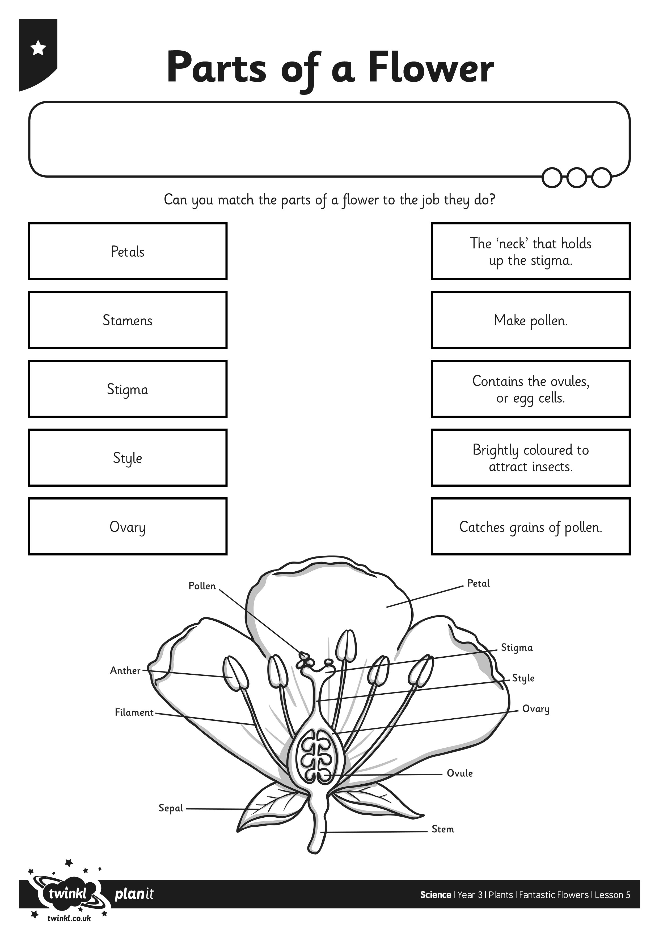
I can name the different parts of a flower and explain their role in pollination and fertilisation.
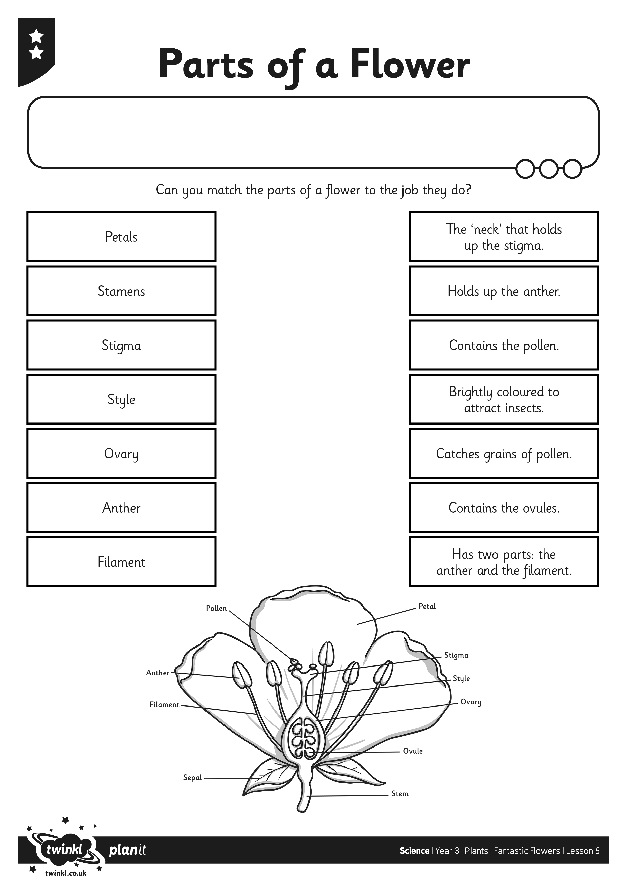
I can name the different parts of a flower and explain their role in pollination and fertilisation.
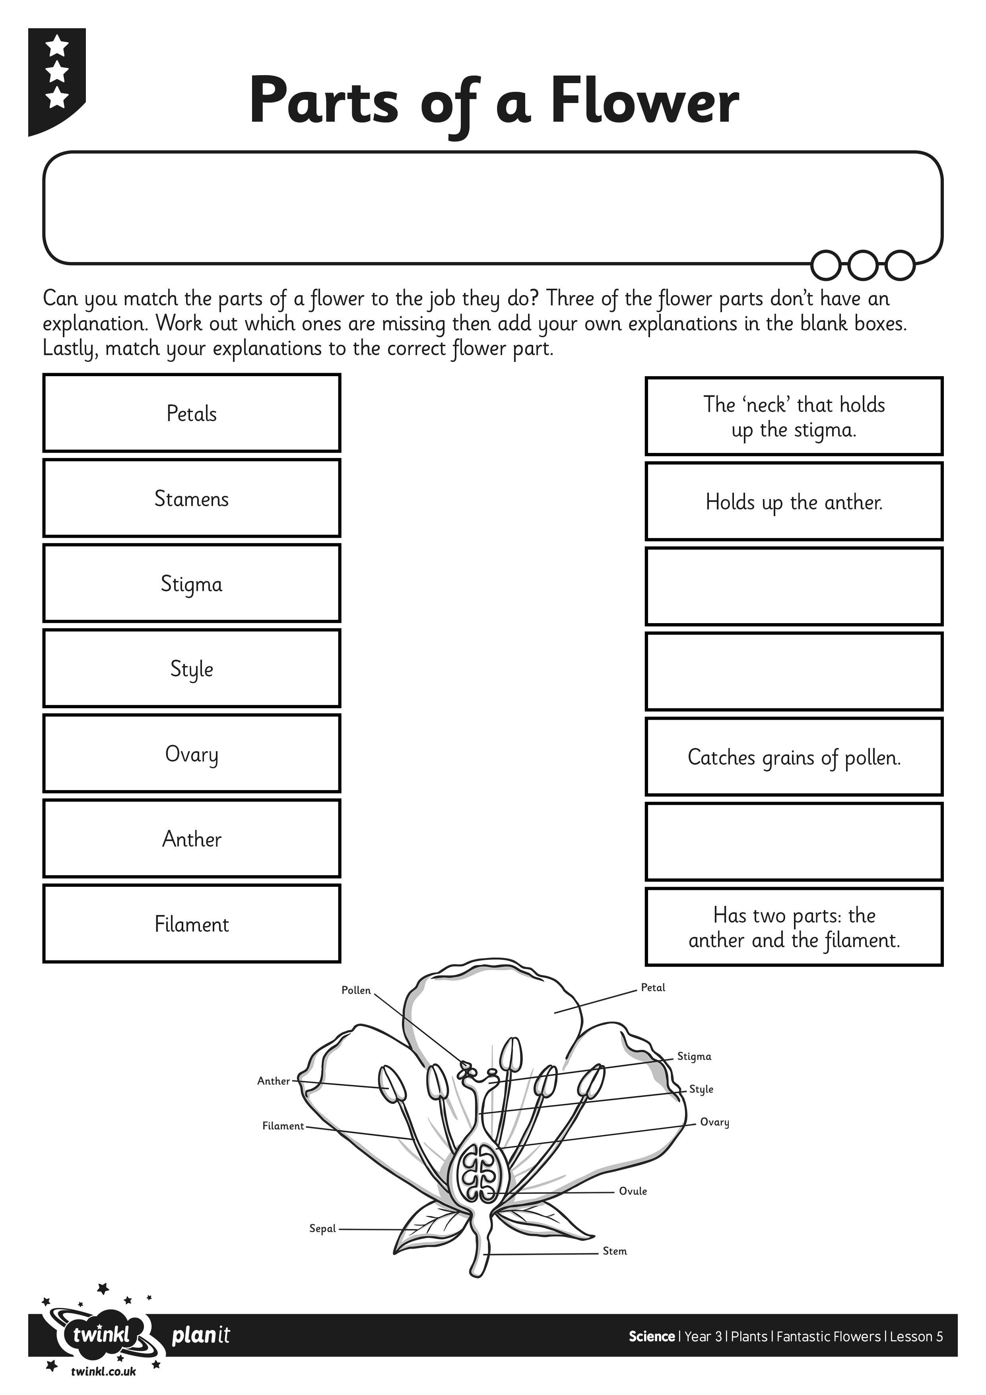
I can name the different parts of a flower and explain their role in pollination and fertilisation.

