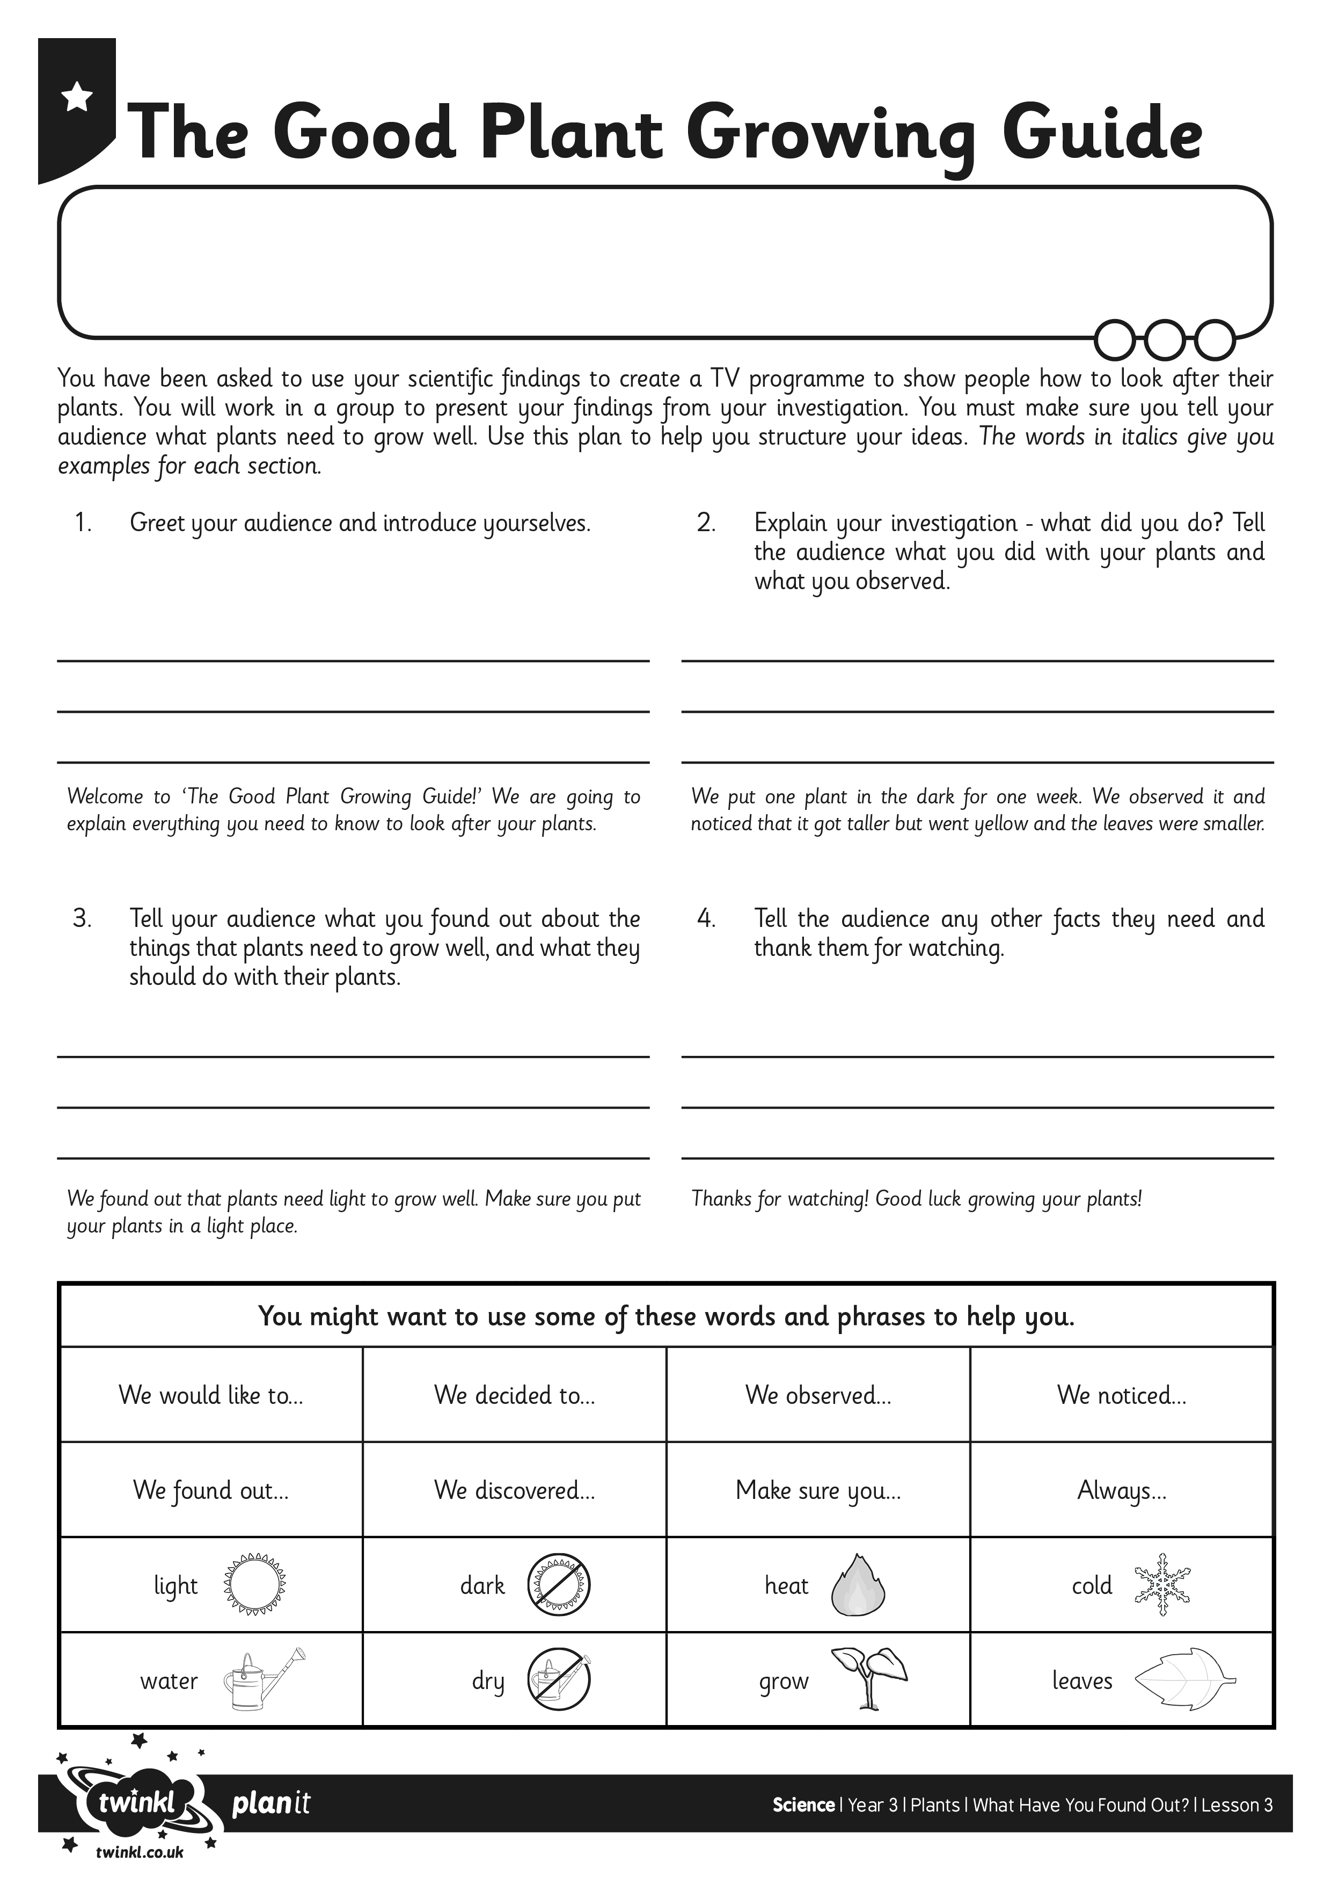
I can present the results of my investigation using scientific language.
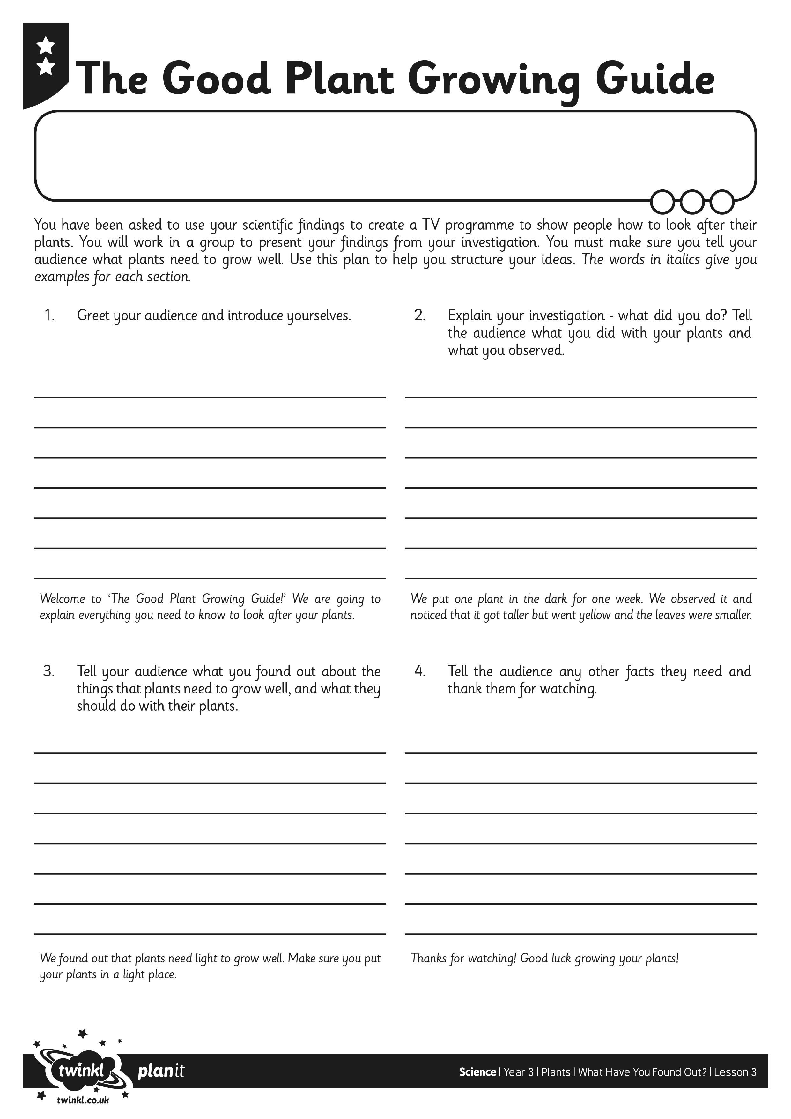
I can present the results of my investigation using scientific language.

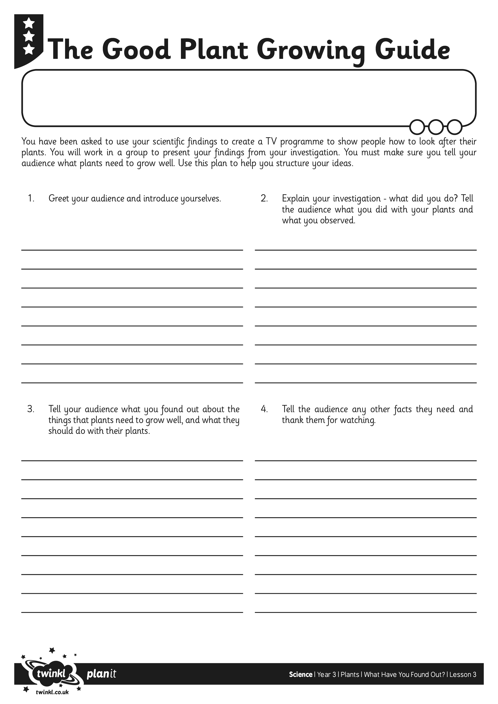
I can present the results of my investigation using scientific language.

